**CC-7182: Programming for Analytics. Spring Semester 2019.**

**DATA EXPLORATORY ANALYSIS USING PYTHON PROGRAMMING ON MARKETTING CAMPAIGN DATASET BASED ON A RETAIL COMPANY.**

**Author: Vinit Gohil**

**Student No: 18024354**

Table of Contents

INTRODUCTION 3

OBJECTIVE 4

**OPEN SOURCE PACKAGE** 4

**Python Files:** 4

**Data Files:** 4

**DATA SET DESCRIPTION** 5

**DATA COMPREHENSION** 7

**DATA PREPARATION AND TRANSFORMATION** 9

**REMOVAL OR CLEANUP OF RECORDS CONTAINING NULL VALUES** 9

**Removing variables with no Influence on the Target Variable** 11

**COLUMN TRANSFORMATIONS** 12

**DATA ANALYSIS** 29

**Summary Statistics** 29

**Correlation** 30

**Euclidean Distance** 32

**DATA EXPLORATION** 33

**DATA MINING** 35

**Decision Tree Model** 35

**Logistic Regression** 37

**DISCUSSION AND REFLECTION OF WORK** 42

# **INTRODUCTION**

This course work report is a detailed reference of executing a Exploratory Data Analysis (EDA) on a retails company marketing campaign dataset. The sole objective of the report is to address how the analyses has been carried out. What are the main aspects of assessing the datasets, how to understand the data and perform the necessary transformations and execute the necessary programmes/scripts to achieve the course objective.

# **OBJECTIVE**

The primary objective of this report is to provide a detailed assessment of how data is being analysed, cleaned, explored and transformed, addressed and visualised all through the programming using python scripting.

## **OPEN SOURCE PACKAGE**

All the data is imported in **Jupyter Notebooks** which is a open source web application that allows one to share live code, equations, visualisations, and narrative text.

* Uses of **Jupyter Notebooks** include data cleaning and transformation, numerical simulation, statistical modelling, machine learning and much more.

### **Python Files:**

* MarketingData.ipynb
* MarketingDTreeModel.ipynb
  + Outputfile: MarketingDataDTree.png
* logR_Marketing.ipynb

### **Data Files:**

* Marketing Campaign data.csv
* ModifiedMarketing.csv
* ModifiedMarketingClean.csv

## **DATA SET DESCRIPTION**

The data used for the coursework is marketing campaign dataset based on a case of a retailer company. The primary objective of the work is to prepare data for further data mining and analysis.

The detailed data description of those data files is given below:

**Marketing campaign data.csv**

The data set contains 1500 customer records. Each record consists of 19 variables, which includes socio-demographic and product ownership information. Variable 11, AFFINITY_CARD (1 = High-value, 0 = Low-value), is the target variable.

All datasets are in CSV format with following attributes:

1. CUST_ID
2. CUST_GENDER
3. AGE
4. CUST_MARITAL_STATUS
5. COUNTRY_NAME
6. CUST_INCOME_LEVEL
7. EDUCATION
8. OCCUPATION
9. HOUSEHOLD_SIZE
10. YRS_RESIDENCE,
11. AFFINITY_CARD
12. BULK_PACK_DISKETTES
13. FLAT_PANEL_MONITOR
14. HOME_THEATER_PACKAGE
15. BOOKKEEPING_APPLICATION
16. PRINTER_SUPPLIES
17. Y_BOX_GAMES
18. OS_DOC_SET_KANJI
19. COMMENTS

In order to comprehend the columns and its’ attributes are within the dataset, it would important to import the dataset into Jupyter Notebook.

The following steps below will present a step by step process of how to understand the data, the process to clean up any dirty, missing or irrelevant data, transformations and visualizations to validate whether the re is any relationship or significant correlation of the variables with the binary variable (AFFINITY_CARD)

## **DATA COMPREHENSION**

To address and see how the data attributes are for the dataset we have to import the data into python. First step will be to import the libraries that will help will importing the files to allow to understand the dataset in more details. For this, libraries like pandas, numpy or csv will be imported and the csv file will be called upon when importing the dataset.

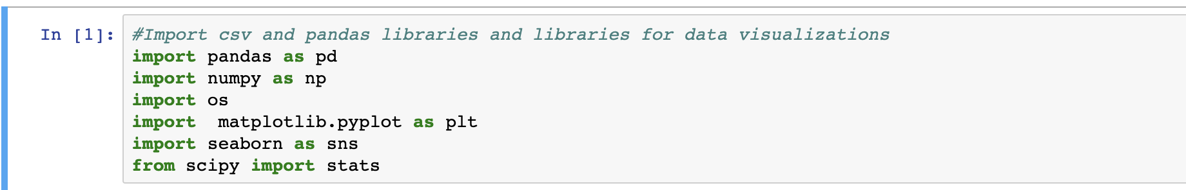

* From the above import statements, the **OS, matplotlib.pyplot**  and **seaborn** libraries have also been imported
* **OS** allows one to determine the file path location of where the file to be imported is. It makes easier to import files if you have different locations or folders where you are importing any csv or text file from.
* **Matplotlib** and **seaborn** libraries will allow with the data visualisations which we will address later during this part of the course.

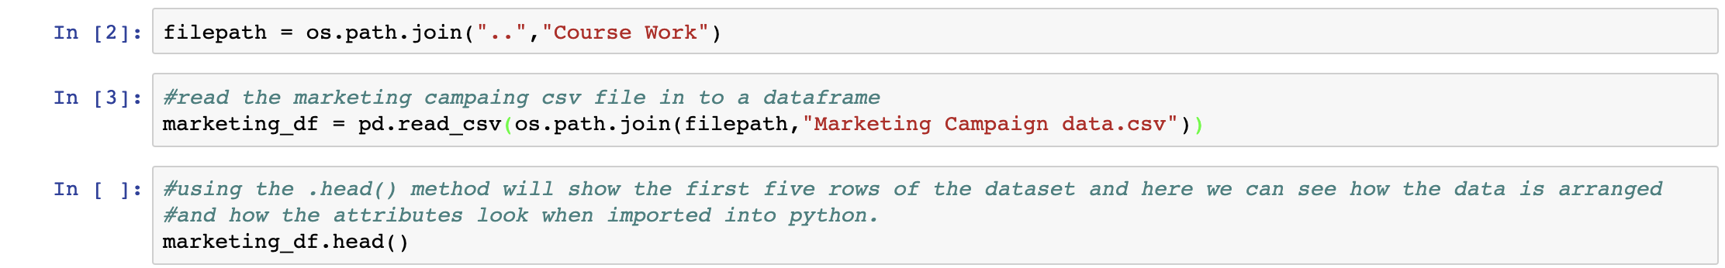

* After importing OS, we can define the filepath:
  + **Filepath = os.path.join(“..”, “Course Work”)**
  + The above command just tell python which folder from the current path where the script is being run from to get the files from.
* Define the dataframe and using pd.read_csv command, import the file. In the above example the dataframe has been defined as **marketing_df.**
* .head() command shows the first five rows of the dataframe. This will show the data and how it has been arranged within the file.

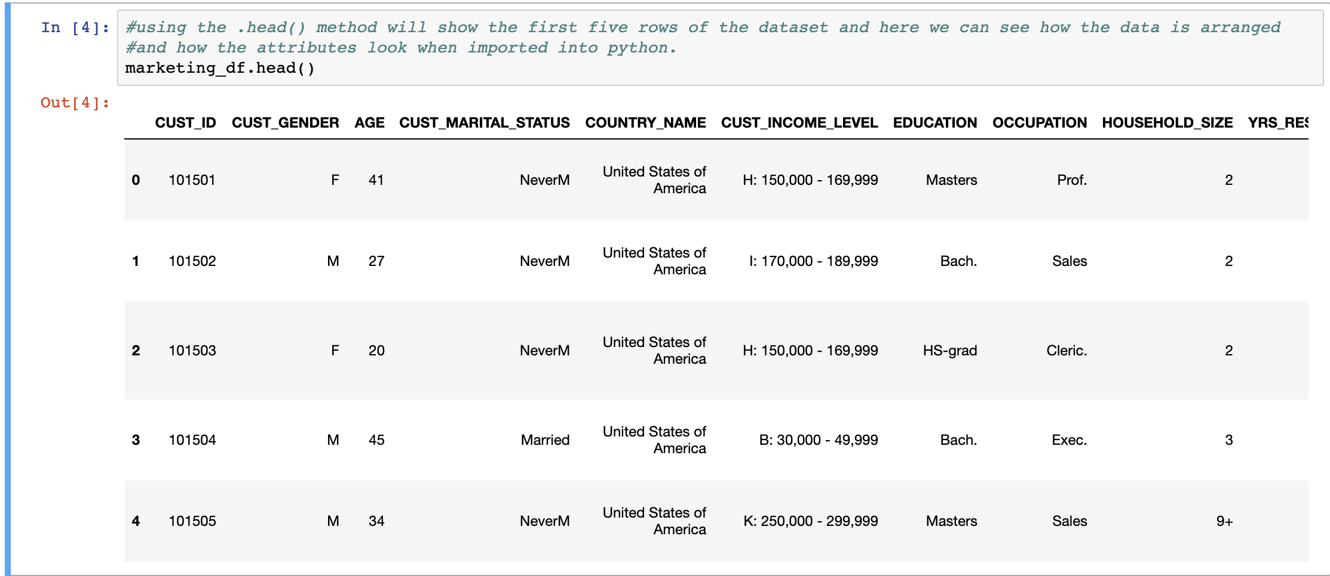

To verify the type of data that has been imported into Jupyter Note Book dataframe, calling the dataframe.dtypes() command will show the attributes of the dataset.

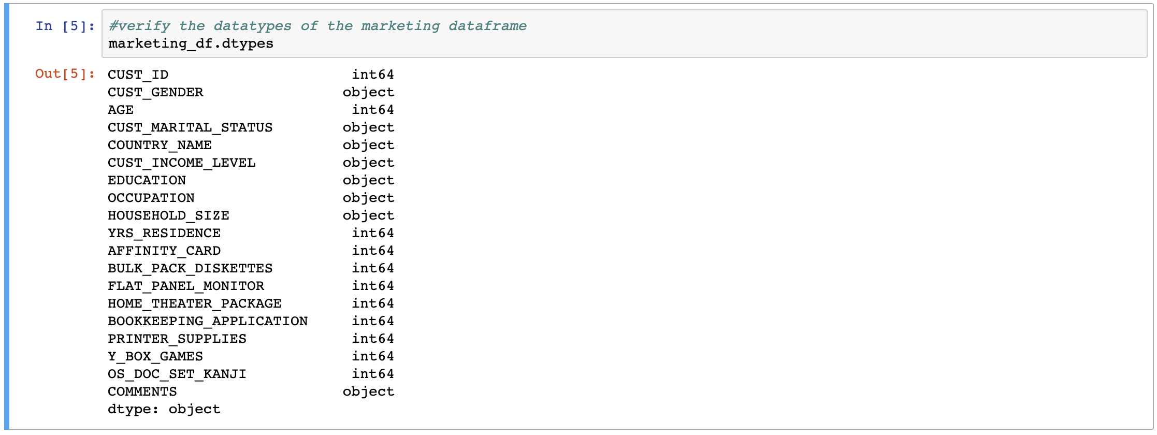

The dtypes confirm that we have most of the column attributes as integer datatype and some columns as object datatype. The object datatype columns like **CUST_GENDER, CUST_MARITAL_STATUS, COUNTRY_NAME** etc, will require some form of transformation when we begin to start processing data with respect to the addressing relationship with the target variable



* To confirm how many rows and columns the dataset has, using the .shape command shows the total number of rows and columns of the dataset. In this instance the dataset contains of 1500 rows and 19 columns.
* As we have imported a dataset that contains a mixture of datatypes, the pandas library will be the most beneficial library here as it is quite powerful with respect to how the data can be cleaned and transformed.

## **DATA PREPARATION AND TRANSFORMATION**

The next steps will be to start cleaning and preparing the data for our data mining purpose. Most data that is collected usually contains missing/null values. This will create a lot of issues with respect to any statistical calculations being conducted. Missing values may construe the skewness of the calculations, so it is important how we normalize these values.

### **REMOVAL OR CLEANUP OF RECORDS CONTAINING NULL VALUES**

Once we have a general understanding of our dataframe. we need to verify if there are any records with missing values or records where the format of the data doesnt conform to the normal standard datatypes. First thing to check within the dataframe is for any missing or null values in records.

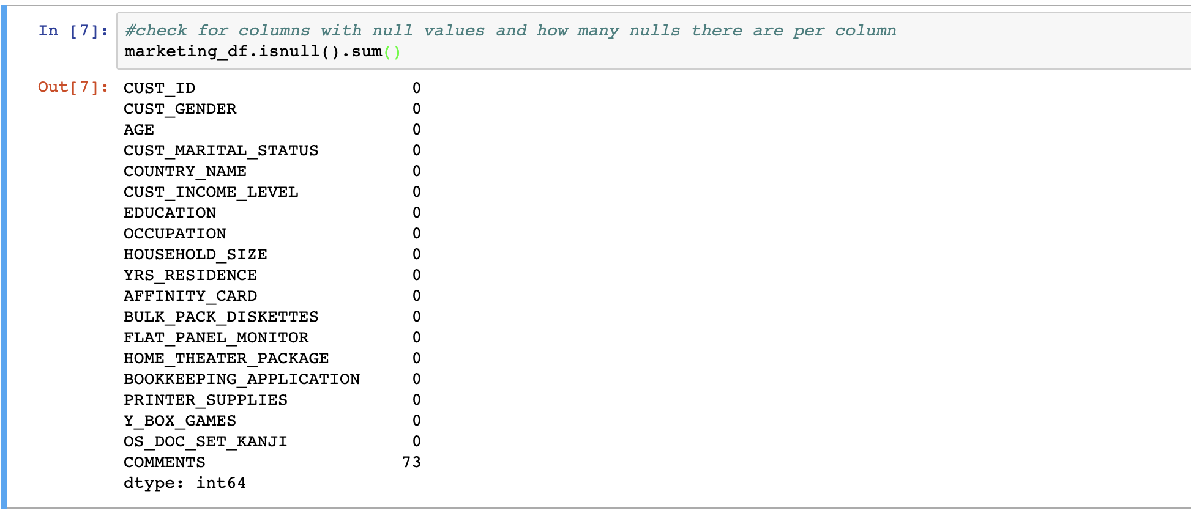

The isnull().sum() method shows that the **COMMENTS** column has a total of 73 records which have null values. At this point you want to either replace the null values or remove them entirely from the dataframe.

The following methods will guide you ways of how one can clean data where data is missing.

#### Solution1: Replace empty/null values with a space

Fill all null or empty cells in your original DataFrame with either an empty space " " or "N/A" and set that to a new DataFrame variable, here, called "**modMarketing_df**"

You can then re-run the .isnull().sum() command to confirm that the COMMENTS total is set to 0.

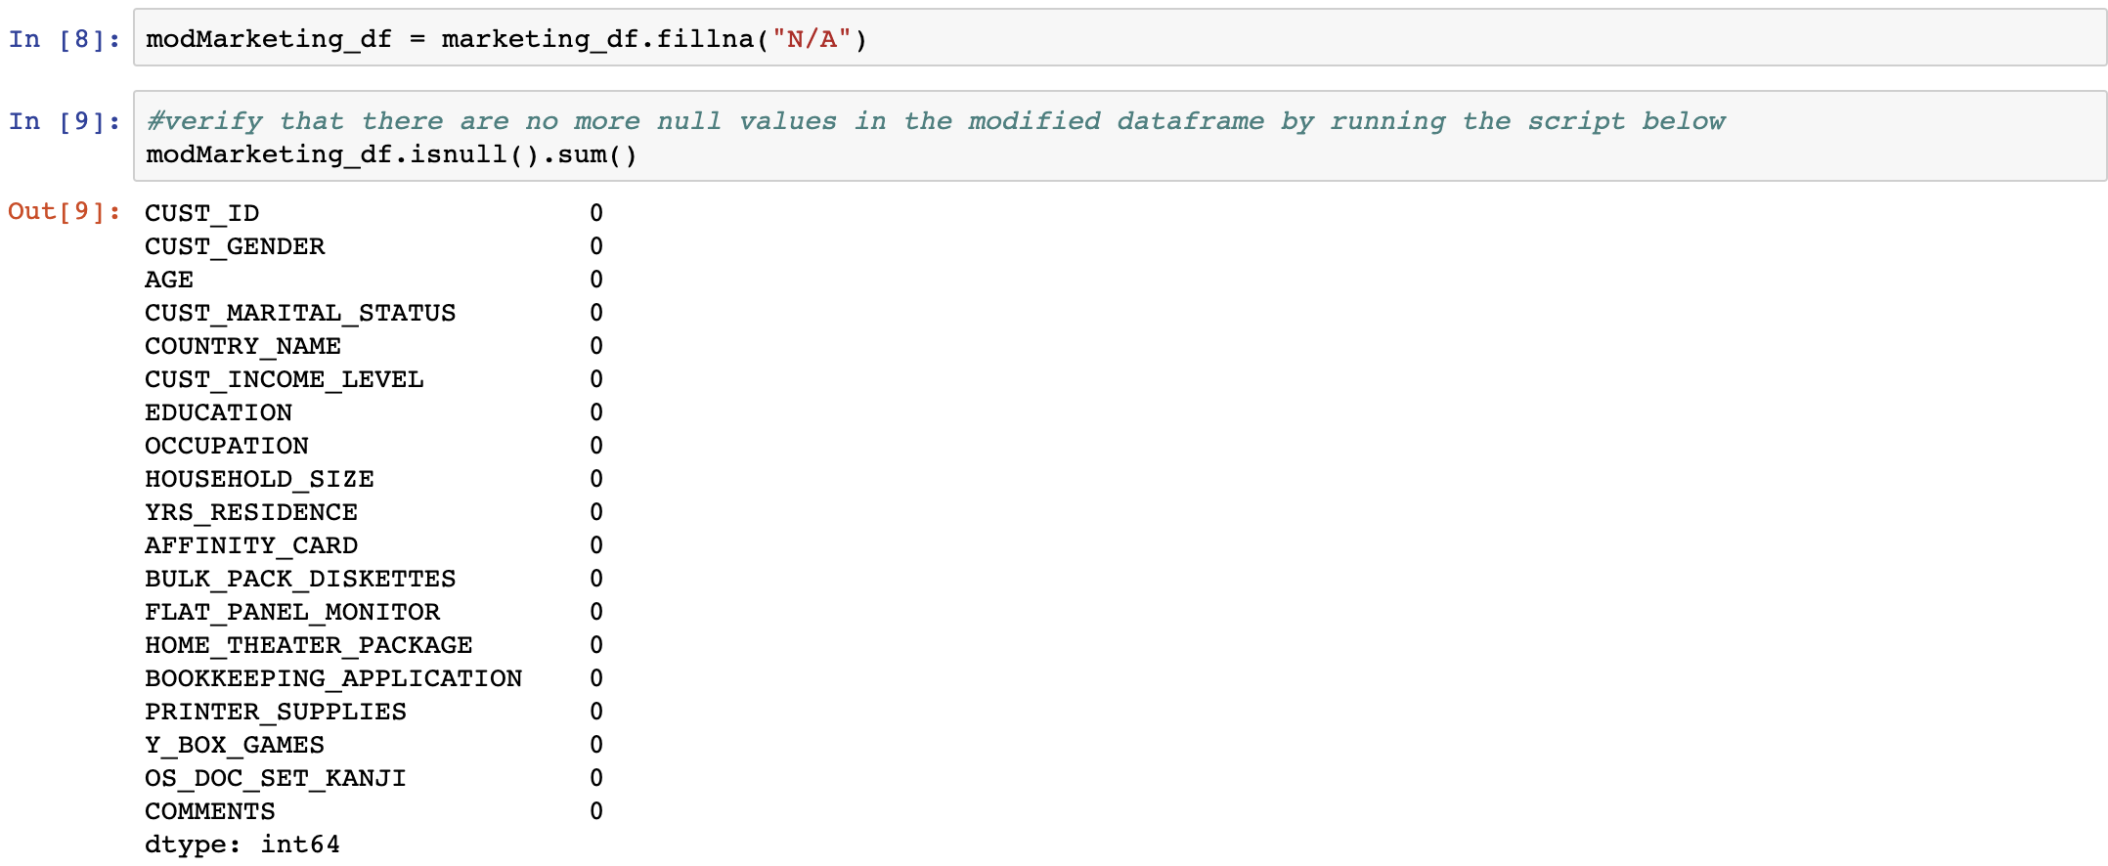

#### Solution 2: Remove rows with empty values

If there are only a few null values and you know that deleting values will not cause adverse effects on your result, remove them from your DataFrame and store that in a new DataFrame "modMarketing_df". Here we can drop the NULL value using the .dropna() command on the dataframe.

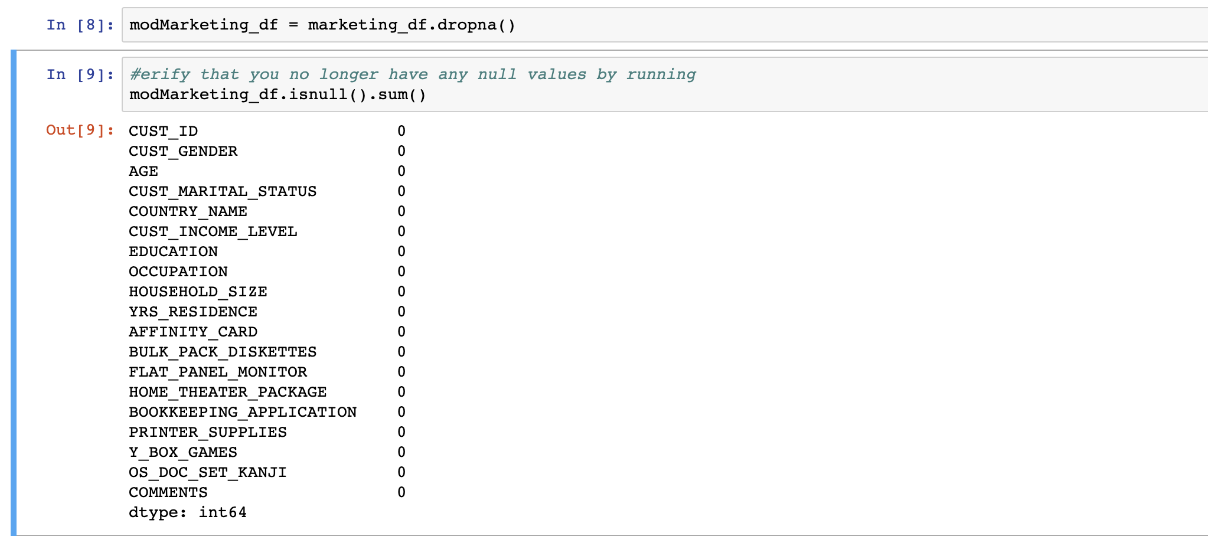

You will achieve the same result however if you re-run the .shape command on the dataframe you will see that 73 rows have been removed from the dataframe.

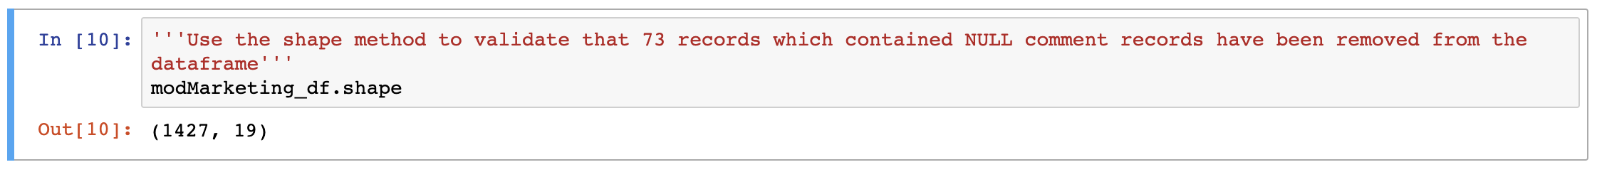

As we have used two examples. The program will use the Method 1 to ensure all 1500 records are still maintained in the dataframe.

### **Removing variables with no Influence on the Target Variable**

We now need to reduce or drop variables from the dataframe that have little or no influence on the target variable **(AFFINITY_CARD**) and **COMMENTS** columns which require dedicated text mining tools.

Looking at the csv file or the dataframe, the columns **CUST_MARITAL_STATUS** , **YRS_RESIDENCE** and **COMMENTS** will have very little influence on the **AFFINITY_CARD** target variable of the dataframe. The following solutions/methods will provide options of how to exclude these columns from the dataframe.

#### Solution 1: use the .loc notation to lock all row indexes and use .column.isin() notation to select the columns that are not required in the dataframe



#### Solution 2: Use the .drop() method to select the columns that need to be dropped from the dataframe. This method uses the axis = 1 label to ensure that the dataframe excludes the desired columns.

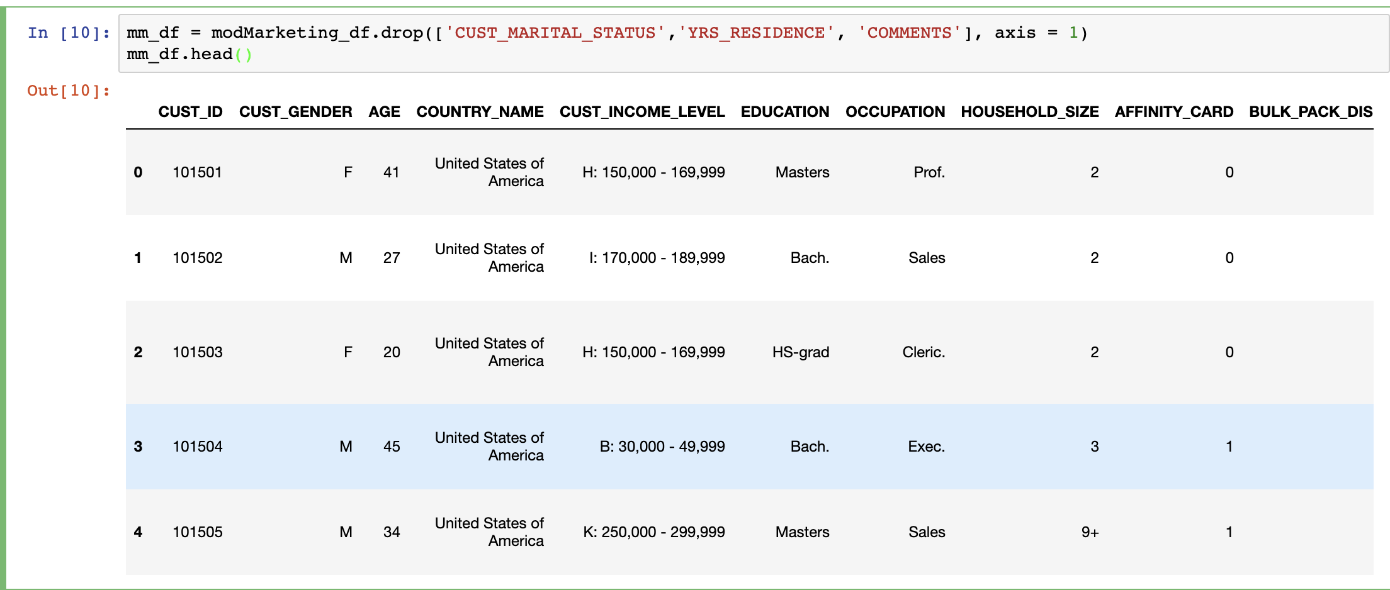

Either solutions above will achieve the same result.

### **COLUMN TRANSFORMATIONS**

This section will focus on transforming some of the object variables in the dataframe and convert these variables into categorical variables.

**CUST_GENDER** into binary F - 0, M - 1 **COUNTRY_NAME** in to ordinal number based on their occurence in the dataset in descending order **CUST_INCOME_LEVEL** into 4 ordinal numbers: 1 - low income (below 50000), 2 - middle income(50000 - 149999), 3 - High income(150000 - 299999), 4 - super rich (300000 and above) **EDUCATION** into ordinal numbers based on the USA Educarion level in descending order **HOUSEHOLD_SIZE** into ordinal numbers based on room number

All the above column variables will be converted in to categorical variables using one or more than one distinct methods/solutions. We shall look at all the aforementioned variables and see how we transform them one by one.

#### CUST_GENDER COLUMN TRANSFORMATION

Solution 1: Use ***replace()*** function to replace the string values with Binary integers.



Solution 2: is a far different method and a longer solution where you can create a dictionary Gender with values 1 and 0 for M and F respectively and then traversing through the dataframe CUST_GENDER column and writing values where the key matches

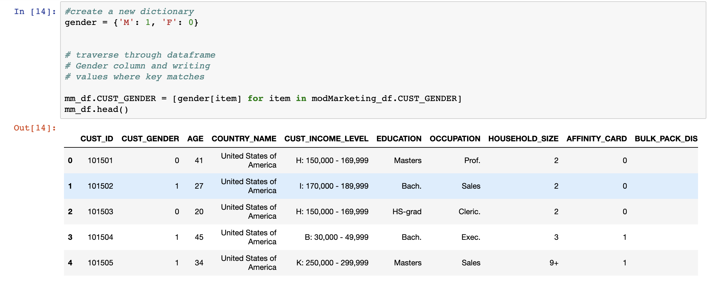

Any of the above methods will provide the same result as the column is transformed in to values 0 for Female and 1 for Male.

#### COUNTRY_NAME COLUMN TRANSFORMATION

To transform the **COUNTRY_NAME** variable into a categorical variable with ordinal values. The first step of action is to verify the frequency distribution of the countries occurring within the dataframe. To do this the **.*value_counts()***method will verify exactly the frequency of each country occurring on the dataframe.

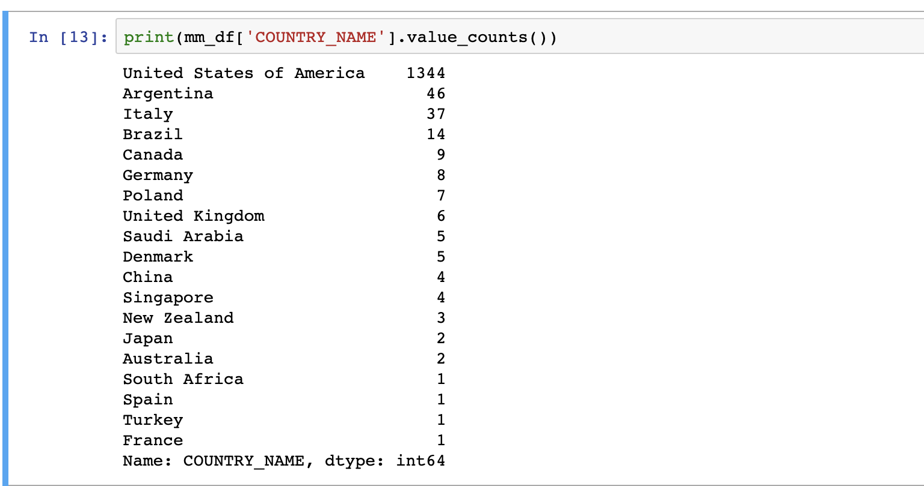

In order to transform the **COUNTRY_NAME** columns in to ordinal values, the most basic method would be to create a simple dictionary mapping each of the countries with a number. This can be achieved with the help of the***.replace()***function in pandas. The idea is that you have the liberty to choose whatever numbers you want to assign to the categories according to the business use case.

Solution 1: create a new dictionary containing the mapping numbers for each country in the **COUNTRY_NAME** column.

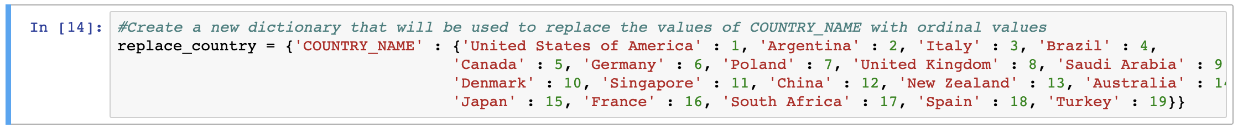

store the country category names in a list called labels and then zip it to a sequence of numbers and then iterate over it

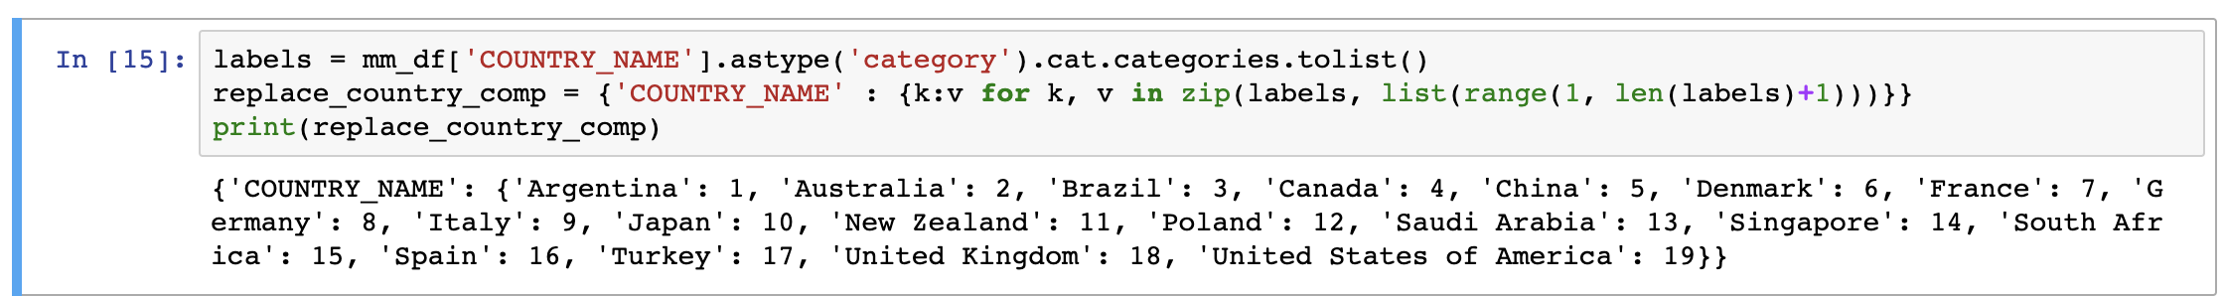

Use the ***.replace()***function on the DataFrame by passing the mapping dictionary as argument

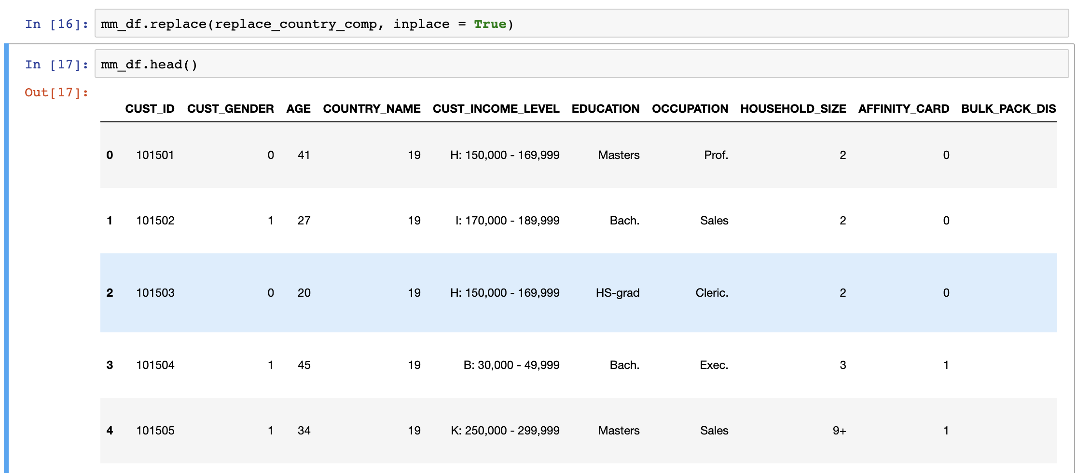

Solution 2: **Label Encoding** - Another approach is to encode categorical values with a technique called "label encoding", which allows you to convert each value in a column to a number. Numerical labels are always between 0 and n_categories-1.

You can do label encoding via attributes ***.cat.codes*** on the DataFrame column. The first step is to convert the column in to a category column before performing the label encoding

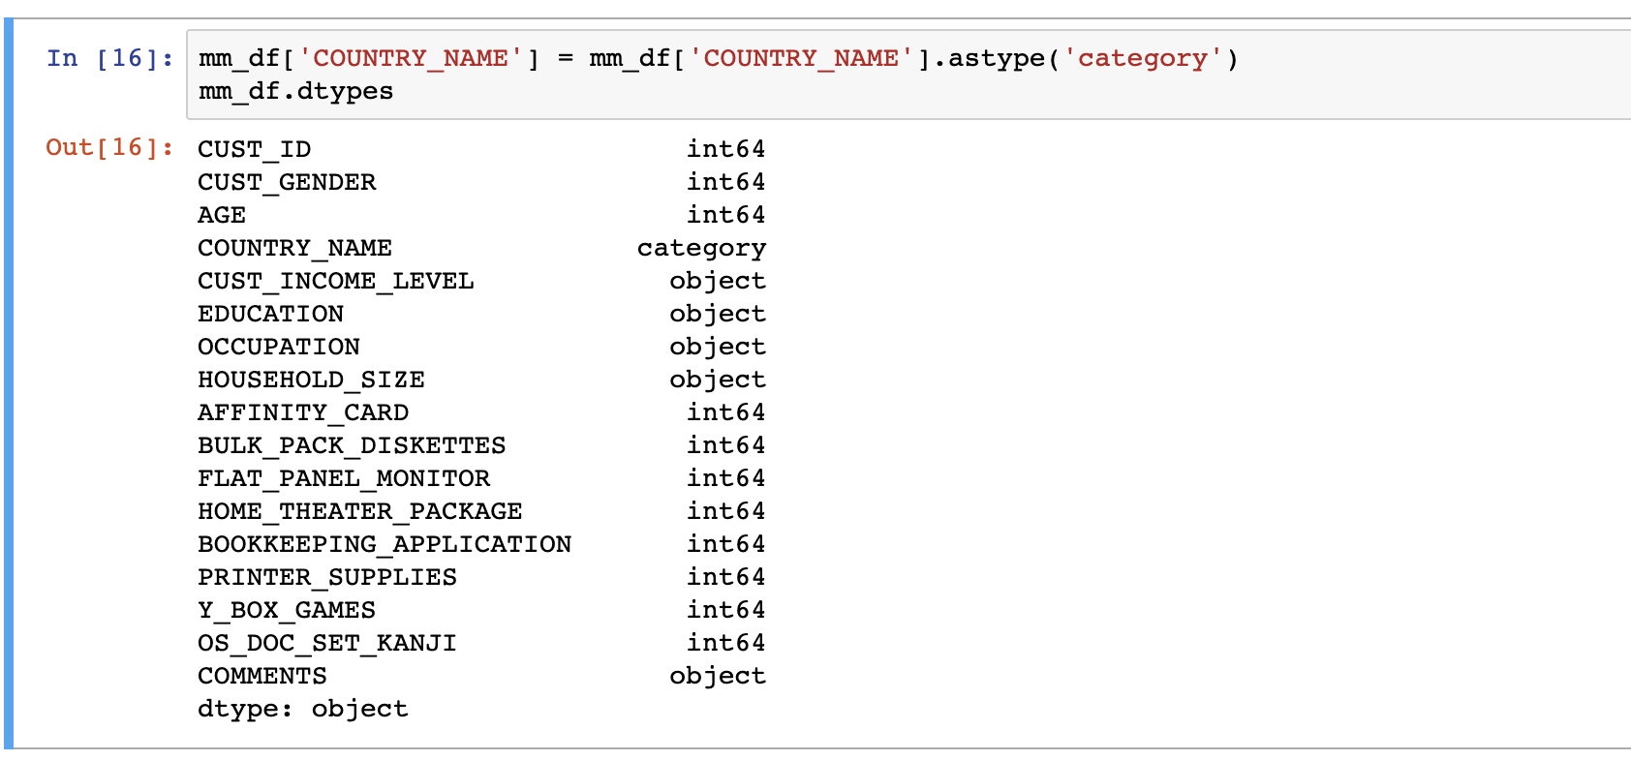

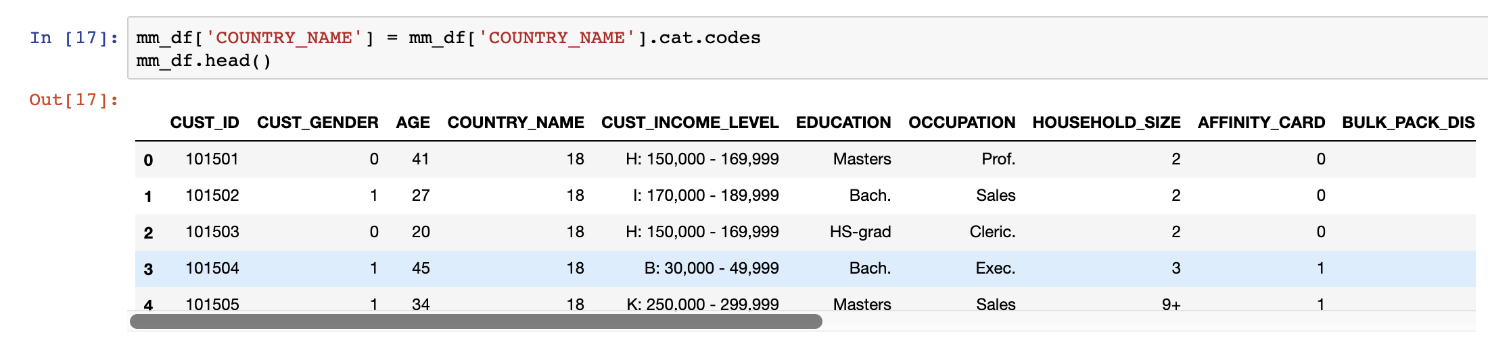

**Note Well:** Using **cat.codes** method enables pandas to auto encode the column to the relevant categorical values it comes across on the dataframe column.

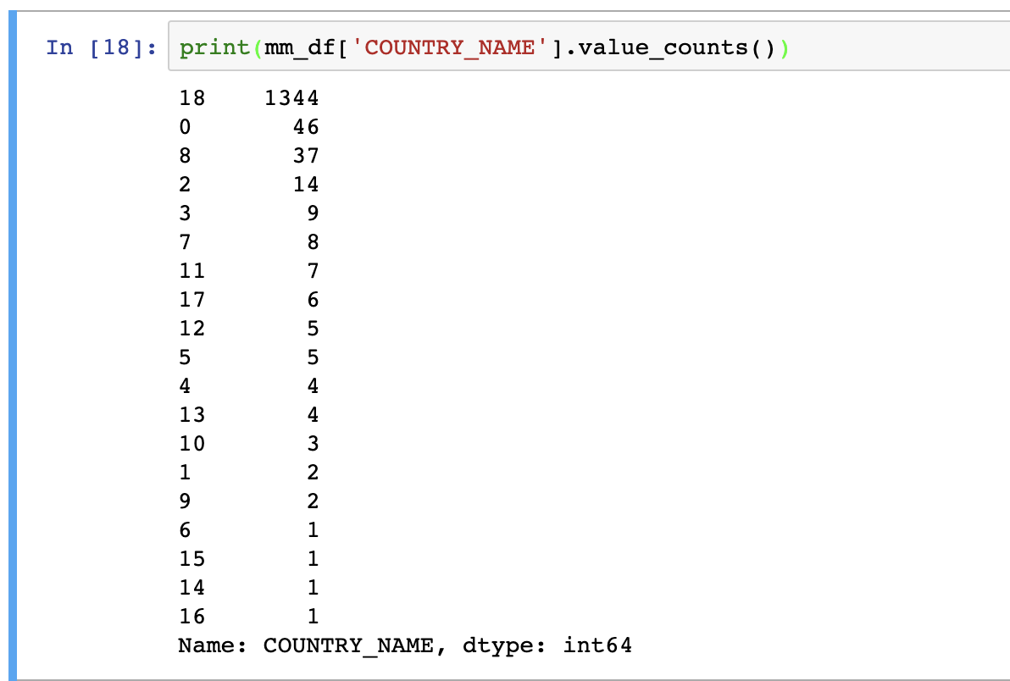

The values of the **COUNTRY** column have now been transformed into integer datatypes. Regardless of which method you use, the transformation will be the same on the column.

#### CUST_INCOME_LEVEL COLUMN TRANSFORMATION

When looking at the **CUST_INCOME_LEVEL** column on the csv file the column contains attributes that are have mixed datatype

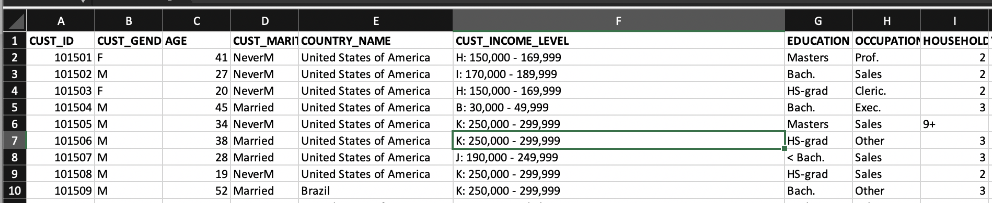

The **CUST_INCOME_LEVEL** column shows the income level of the customers. In order to categorise the column, we need to do some clean up from the imported csv file as there are unwanted characters in the column that do not conform with the values which could skew the results of the ongoing data analysis. Before we proceed, we must verify the distinct counts of values within the columns

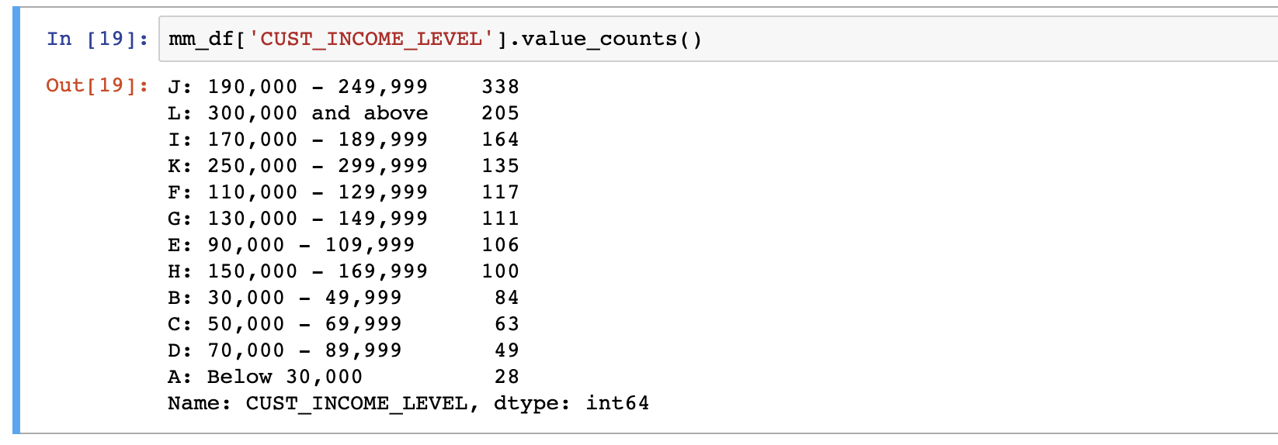

Solution 1:

From the counts we can see that there are values contain characters strings for which we want to remove the first two string containing the Capital letter and the colon (:) characters from the column. To do this we can use the ***lambda*** function to ***strip*** the first two characters of the string from the column.

mm_df['CUST_INCOME_LEVEL'] = mm_df['CUST_INCOME_LEVEL'**].map(lambda x: str(x)[3:])**

* The map lambda function will allow one to explicitly remove the first three characters of the string value and only leave the salary range intact.

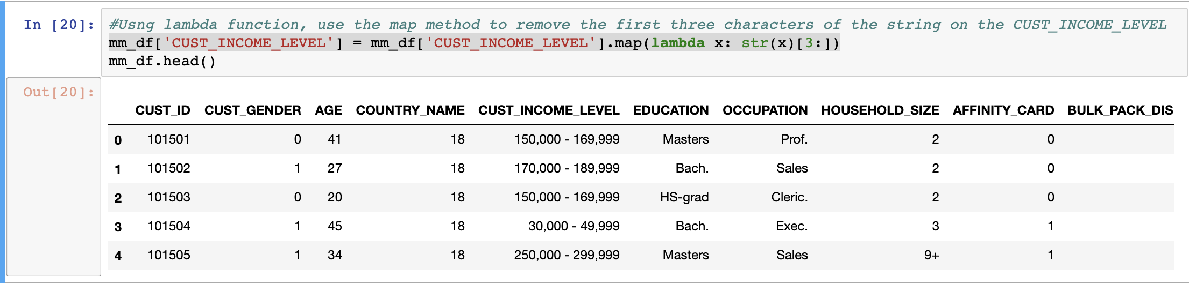

We can now proceed with categorising the salary range just as we have like the previous columns using the dictionary key:value pair.

The assignment criteria for the CUST_INCOME_LEVEL columns is as follows:

* CUST_INCOME_LEVEL into 4 ordinal numbers 1 – low income (below 50,000), 2 – middle income(50,000 - 149,999), 3 – high income (150,000 - 299,999), 4 – super rich (300,000 or above)

To achieve the above, we can use a simple transformation of assigning key:values pair to the salary ranges that have been defined on the dataset.



The ***.dtypes*** command confirms the datatype to be object datatype for the **CUST_INCOME_LEVEL** column

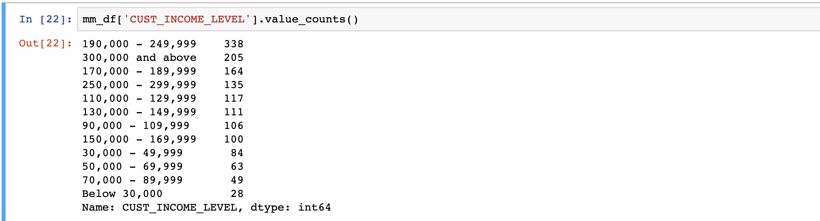

We confirm the distinct number of rows with the salary ranages.

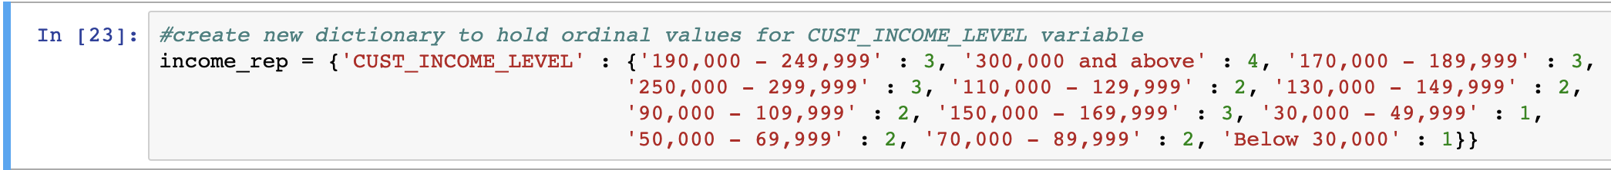

Create a Dictionary (**income_rep**) for **CUST_INCOME_LEVEL** column and define the value of each range based on the criteria specified.

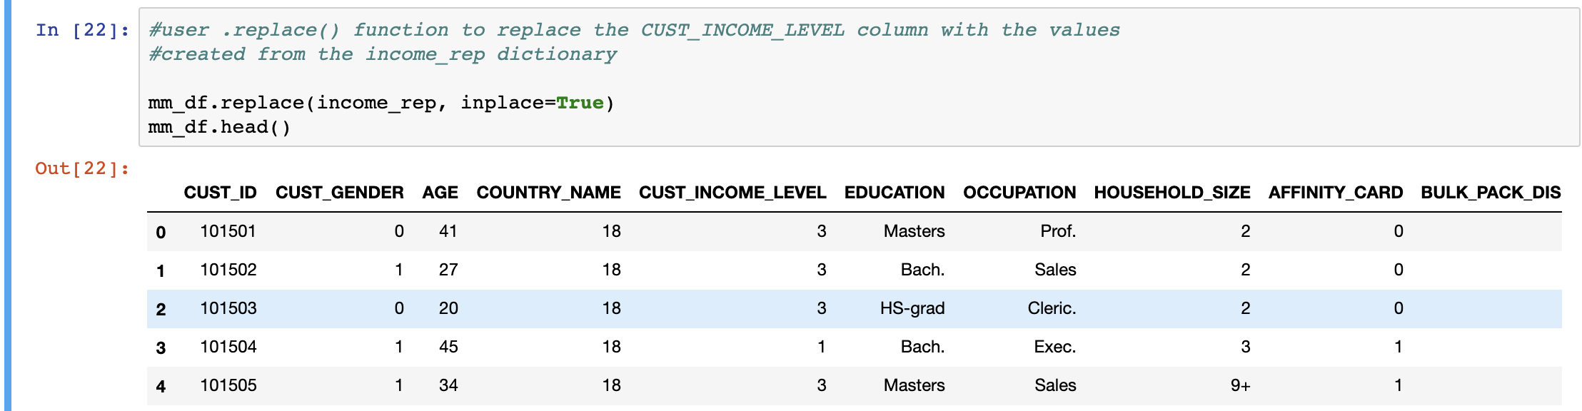

Use **.replace()** to replace the values of the dictionary into the **CUST_INCOME_LEVEL** column. This affirms the column now to be correctly categorised.



The ***.dtypes*** command on the column now confirms the column transformed to an Integer datatype.

Solution 2:

Using the same lamda function as used in solution 1, strip the values of the first three characters.

Create a new function (**income_code**). This is a manual process where the range of values of customer level income will need to be split between low and high income and the custom income level manually categorised based on the criteria provided. 1 - low income (below 50,000), 2 – middle income(50,000 - 149,999), 3 – high income (150,000 - 299,999), 4 – super rich (300,000 or above)

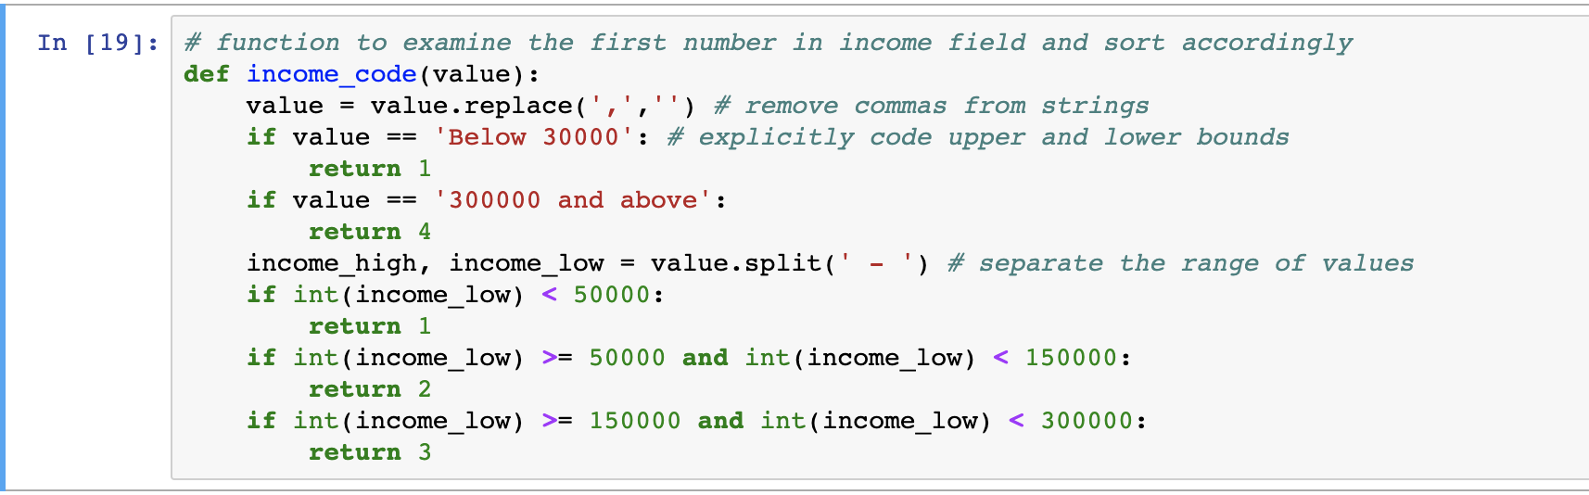

Then apply the function on the dataframe column to transform the values into the codes defined on the function.

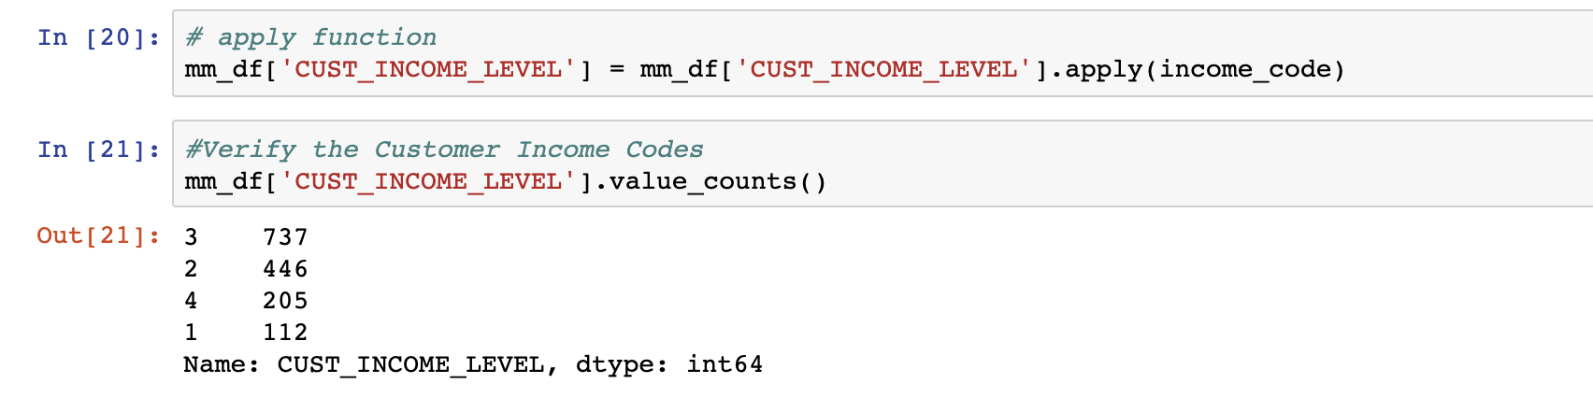

Verify the codes have been applied to the dataframe.

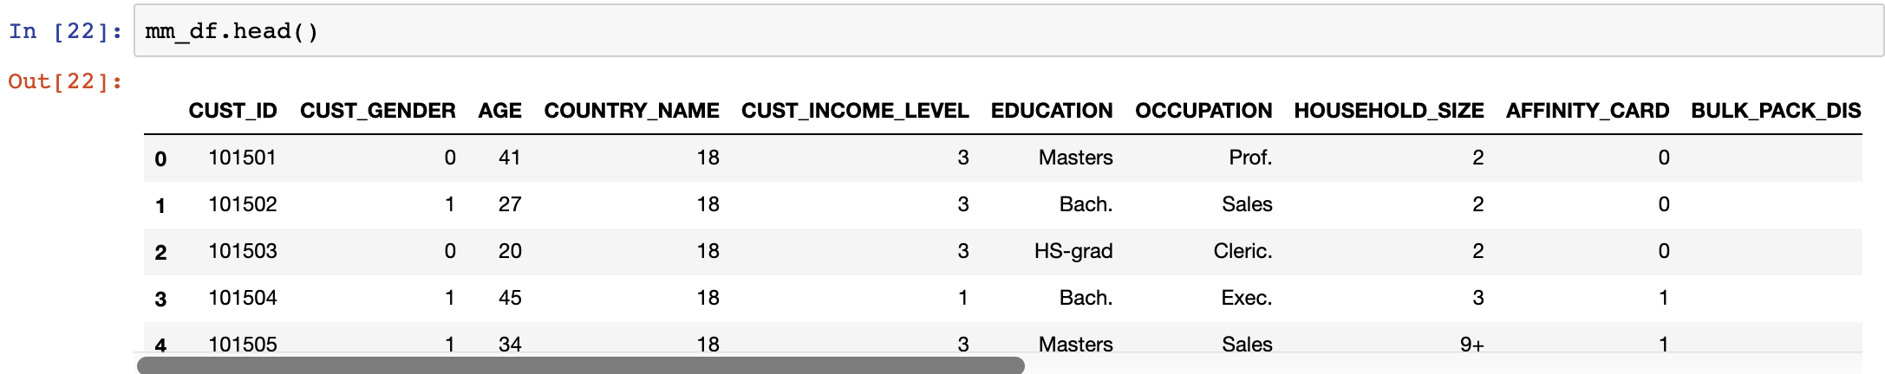

#### EDUCATION COLUMN TRANSFORMATION.

The **EDUCATION** column is another category which will have to be converted into a categorical column. Just like the previous **CUST_INCOME_LEVEL** column **Label Encoding,** the same method will be applied here for this column to transform the values into ordinal numbers based on the USA education level.

We must first confirm the distinct number of values within the**EDUCATION** column based

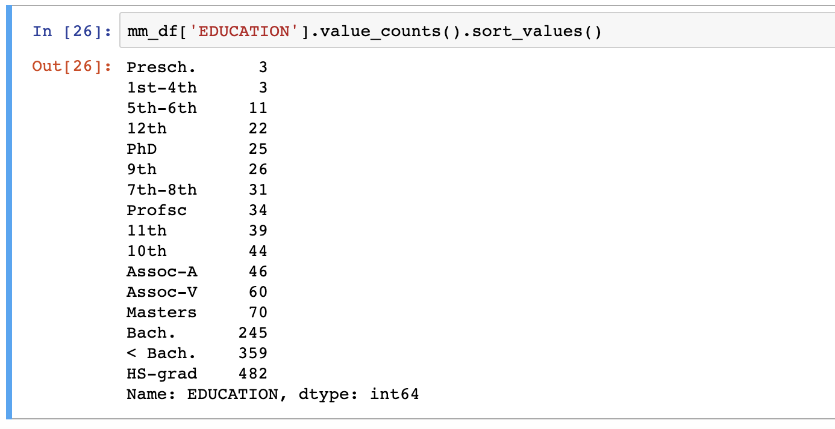

Solution 1: Like before, we can create a new dictionary (**Edu_rep**)based on the **EDUCATION** keys and assign them each a value and then use the **replace** function to replace the value into the **EDUCATION** column**.**

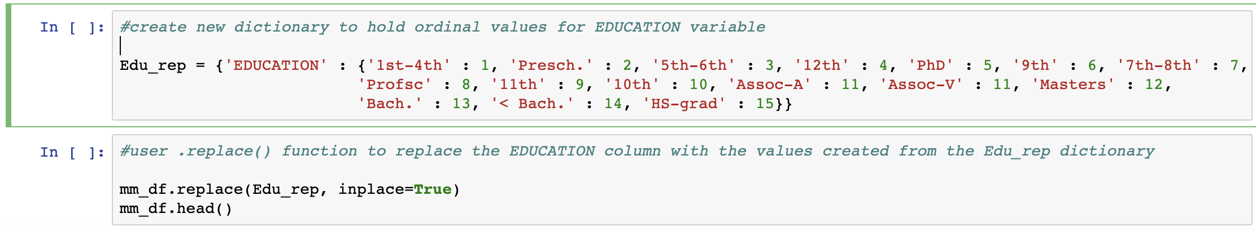

Solution 2: As before we can transform the column in to a categorical variable using the .***astype(category)*** function, and then perform label encoding using ***.cat.codes*** function on the column itself.

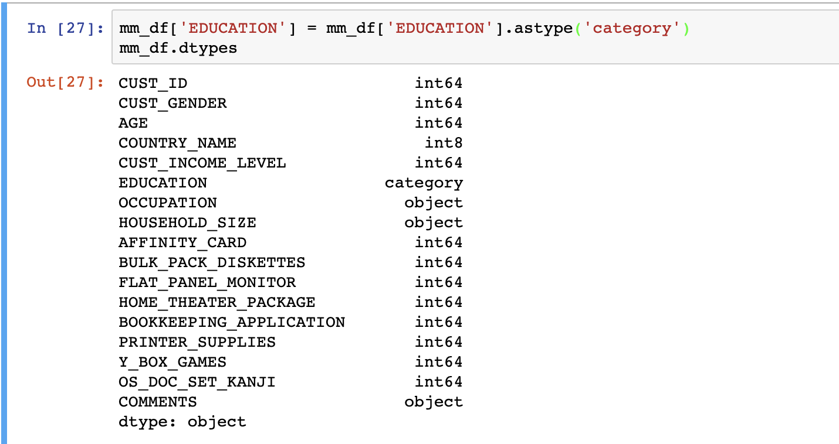

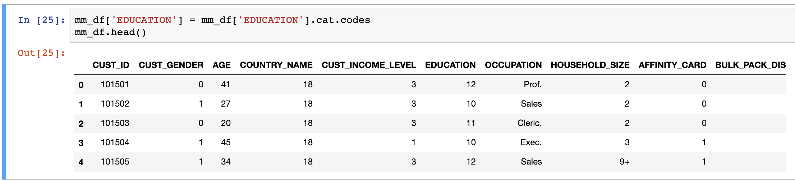

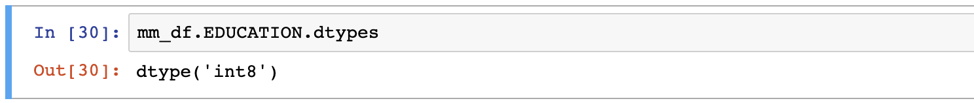

The **.dtypes** command on the column confirms that column datatype has been converted to integer.

An additional criteria concerning the **EDUCATION** column:

* EDUCATION into ordinal numbers based on USA education level in ascending order.

Using **.sort_values(by=[’EDUCATION’])** will have the dataframe sorted by the education catergory in ASCENDING order. (i.e from the smallest to the largest value)

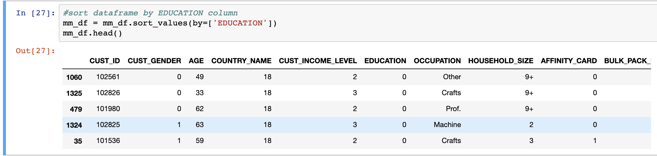

#### HOUSEHOLD_SIZE COLUMN TRANSFORMATION

The criteria specified for HOUSEHOLD_SIZE column transformation:

* HOUSEHOLD_SIZE into ordinal numbers based on room number

This requirement is a little vague as we do not have the room number/s on the dataset that was imported. We can however confirm the distinct values for the columns using the .***value_counts()*** function to verify what values exist for the column

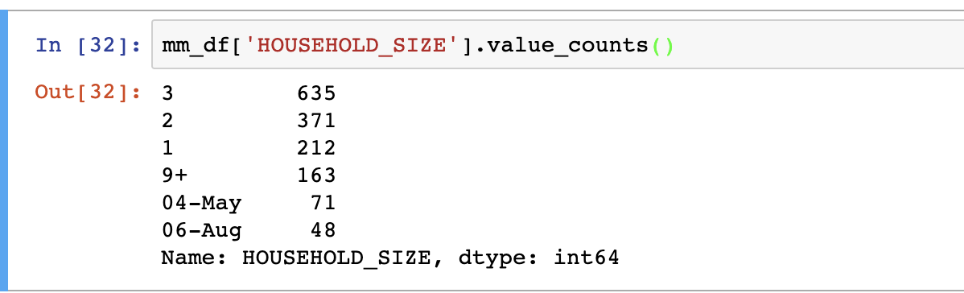

**Please Note:** This column contains some 'dirty data' and it is important that column values that make no sense or add any value to the overall dataset be either identified by another value in this example. Values **'04-May'** and **'06-Aug'** are obviously datetime values which add no meaning to the column. In order to rectify this problem one can either replace the variables with different values or remove the records containing the above values from the dataset.

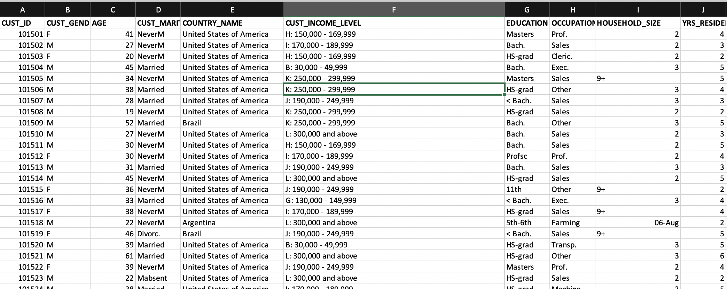

Solution 1: Update value of **HOUSEHOLD_SIZE** column for values **'04-May'**,**'06-Aug'** & **'9+'** to 1, 2 & 4 respectively

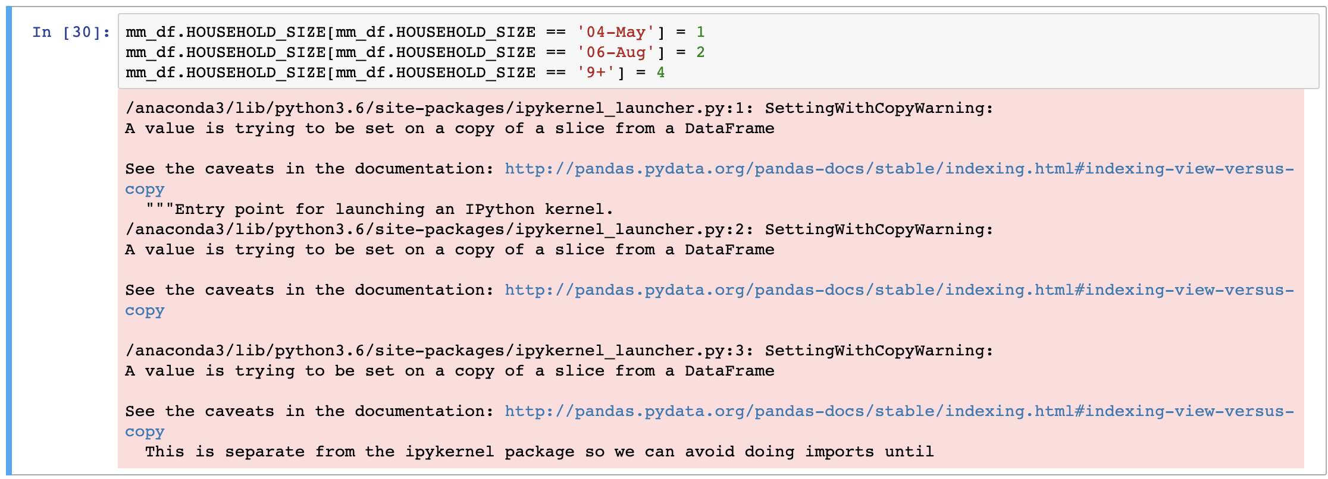

Change the datatype of the column to integer





**HOUSEHOLD_SIZE** column has now been transformed.

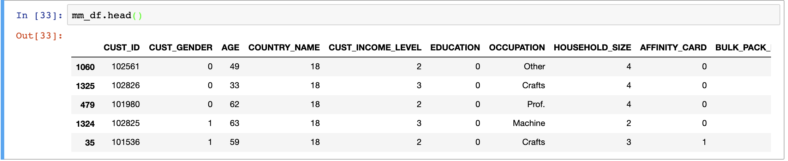

#### OCCUPATION COLUMN TRANSFORMATION

This columns contains data where some occupations have not been correctly identified. There is a value of '?' within this column which ideally needs to be replaced in-order for the data to be accurately correlated with respect to the overall data.

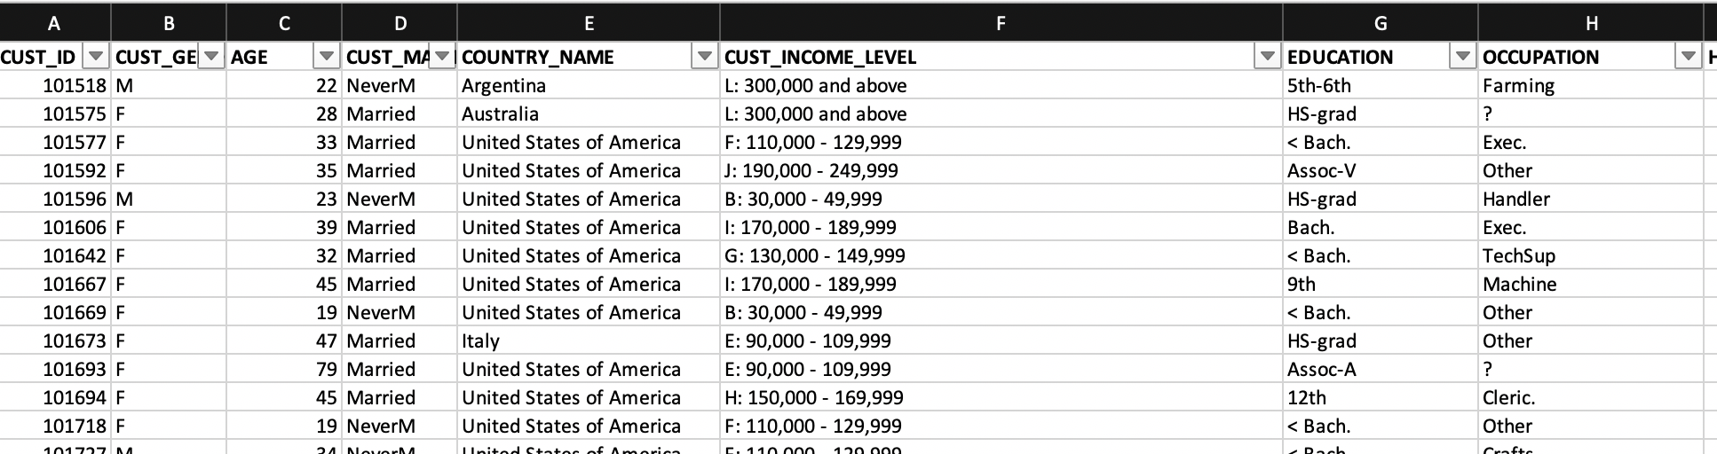

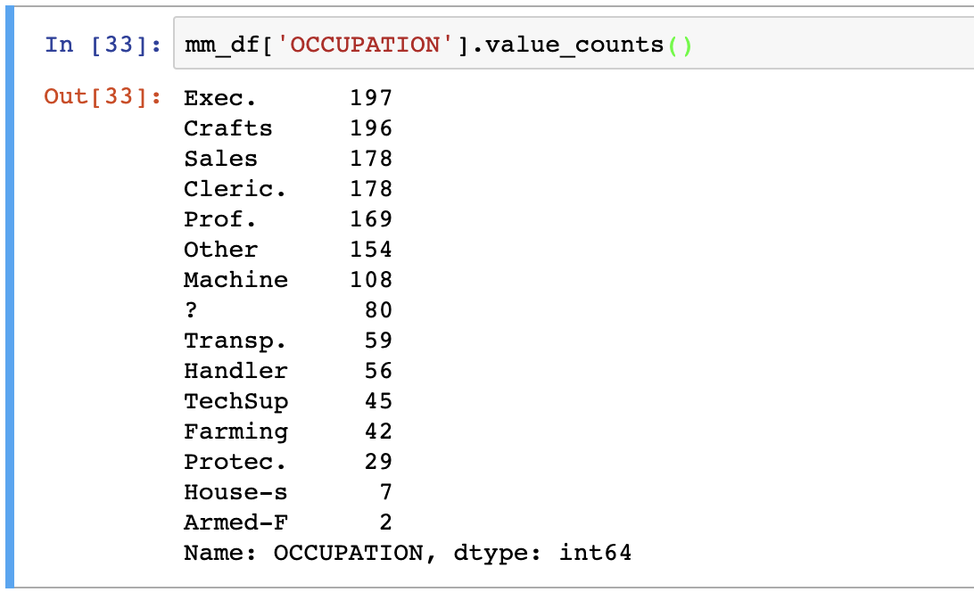

As from the **value_counts,** an Occupation of ‘?’ does not add any value to the dataset and this will either have to be rectified or any value where this record is occurring will need to be replaces by a different occupation string. There are 80 records in the dataframe where this occupation is missing.

We first address what data type the column attribute is.

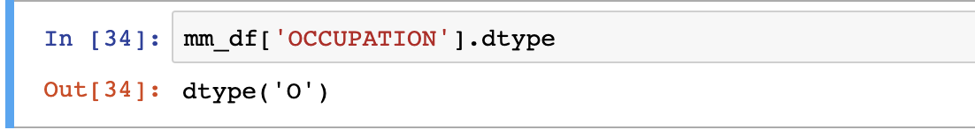

The column above is an object column.

We must also strip/clean away the string occurrences of ‘.’ (dot) notation on some of the occupations like ‘Exec.’, ‘Prof.’, ‘Cleric.’, as this will likely interfere when running data mining analysis against categorical string values.

Inorder to remove the ‘.’ Notation we first convert the datatype of the column to string and then we can use rstrip to remove occurrence of dot. The command line below will perform all the data cleanup and transformation in one go.



We can then proceed with replacing the ‘?’ occurrence of Occupation with something that you can define. In this example I have replaced the value with ‘Unknown’ as the Occupation of the person within the dataframe is not confirmed.



We can now confirm how the **OCCUPATION** datatype and column values look like following the above cleanup.

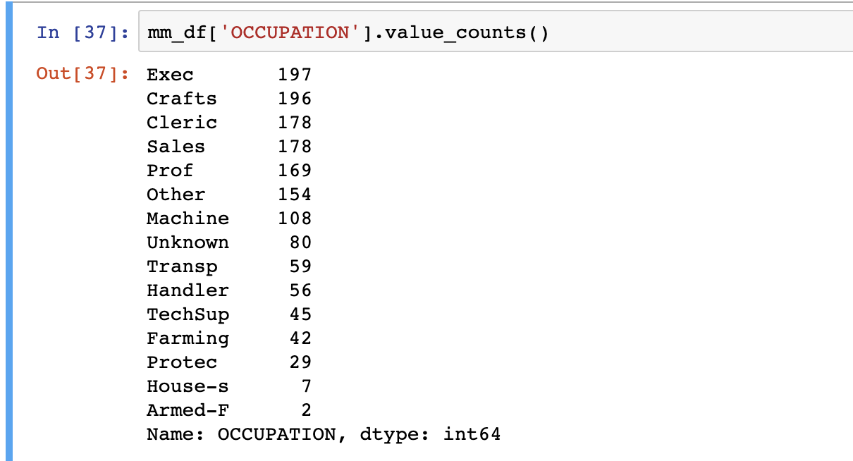

We have now mostly transformed most of the categorical columns required for the dataset and prepared the data to now performing our Data Analysis on.

We can confirm that all the data is now categorised as we need.

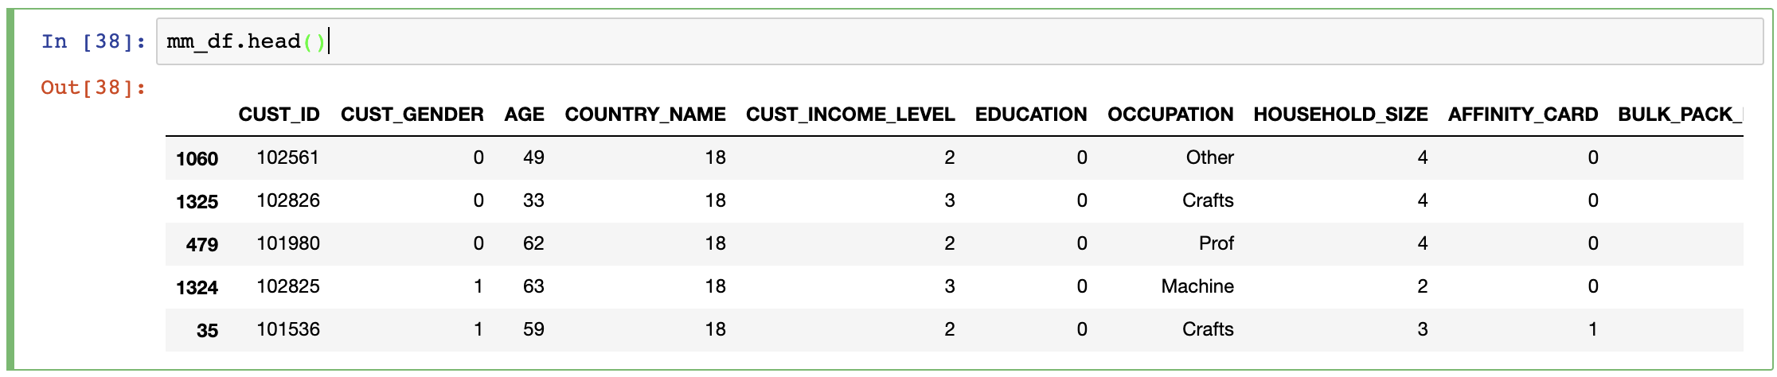

**Please Note:** Before proceeding with Data Analysis, it is also important to read the dataframe into a new csv file for future reference. This file will be important on performing Data Mining analyses. It will be important to use the transformed dataset to run your supervised learning models that you build in python.

The command below saves the file as a comma delimited file (**“ModifiedMarketingClean.csv”**).



## **DATA ANALYSIS**

This section the assignment criteria is to define a program that will show the summary statistics of any chosen variable within the dataframe.

### **Summary Statistics**

Summary Statistics will include the SUM, MEAN, MAX, MIN, PERCENTILES, VARIANCE, SKEWNESS and KURTOSIS of any chosen variable from the dataframe.

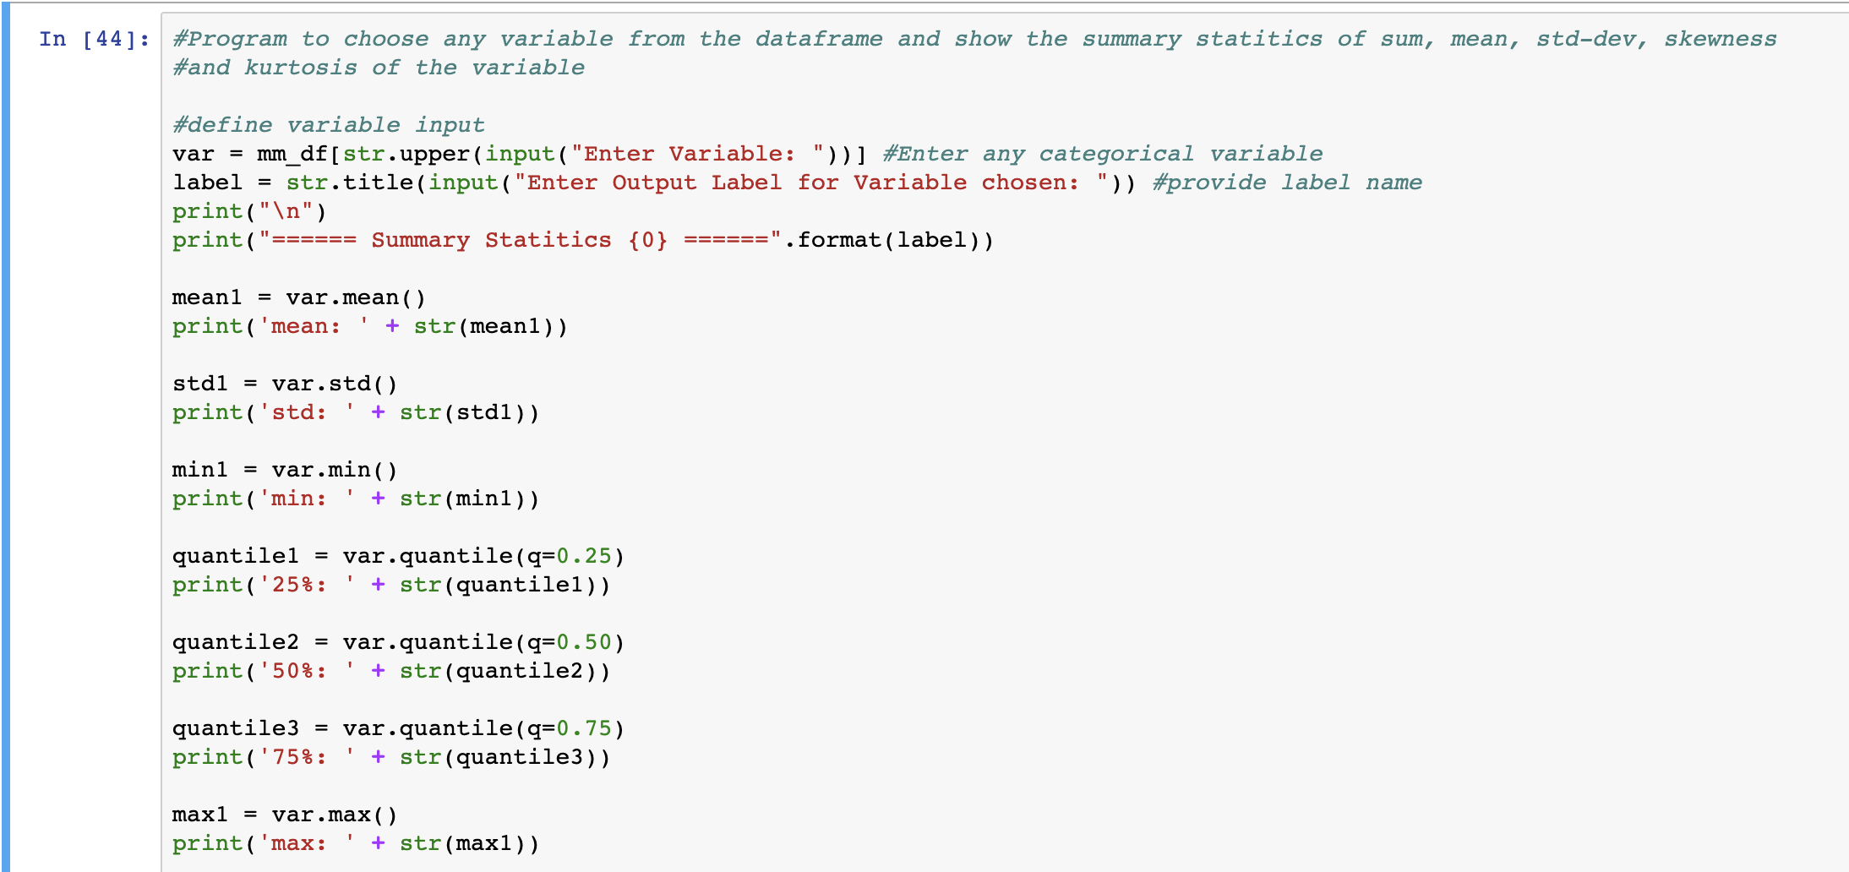

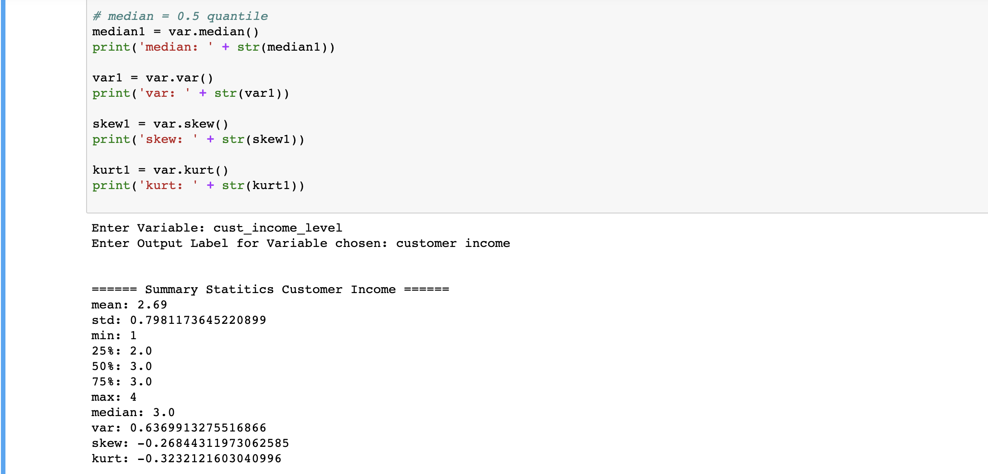

### **Correlation**

To address the correlation of ALL the variables with the target variable, the ***.corr()***function will show whether any variables are closely correlated to each other. By sorting the values with the target variable will allow to view the correlation more clearly in descending order using the ***.sort_values()*** function to the dataframe

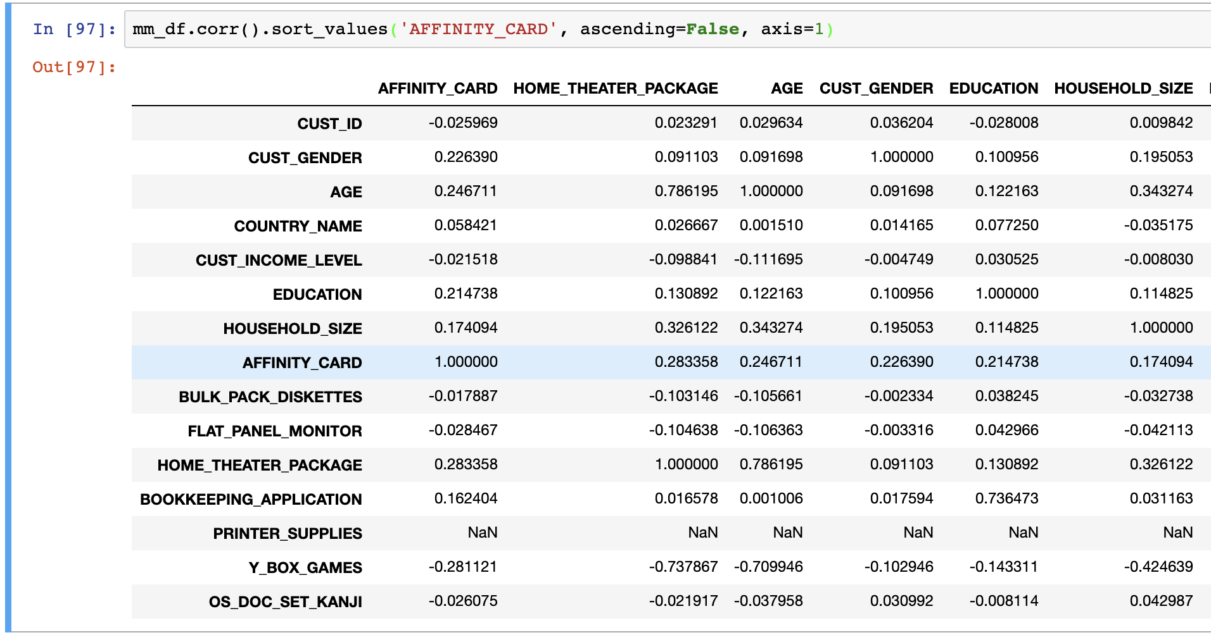

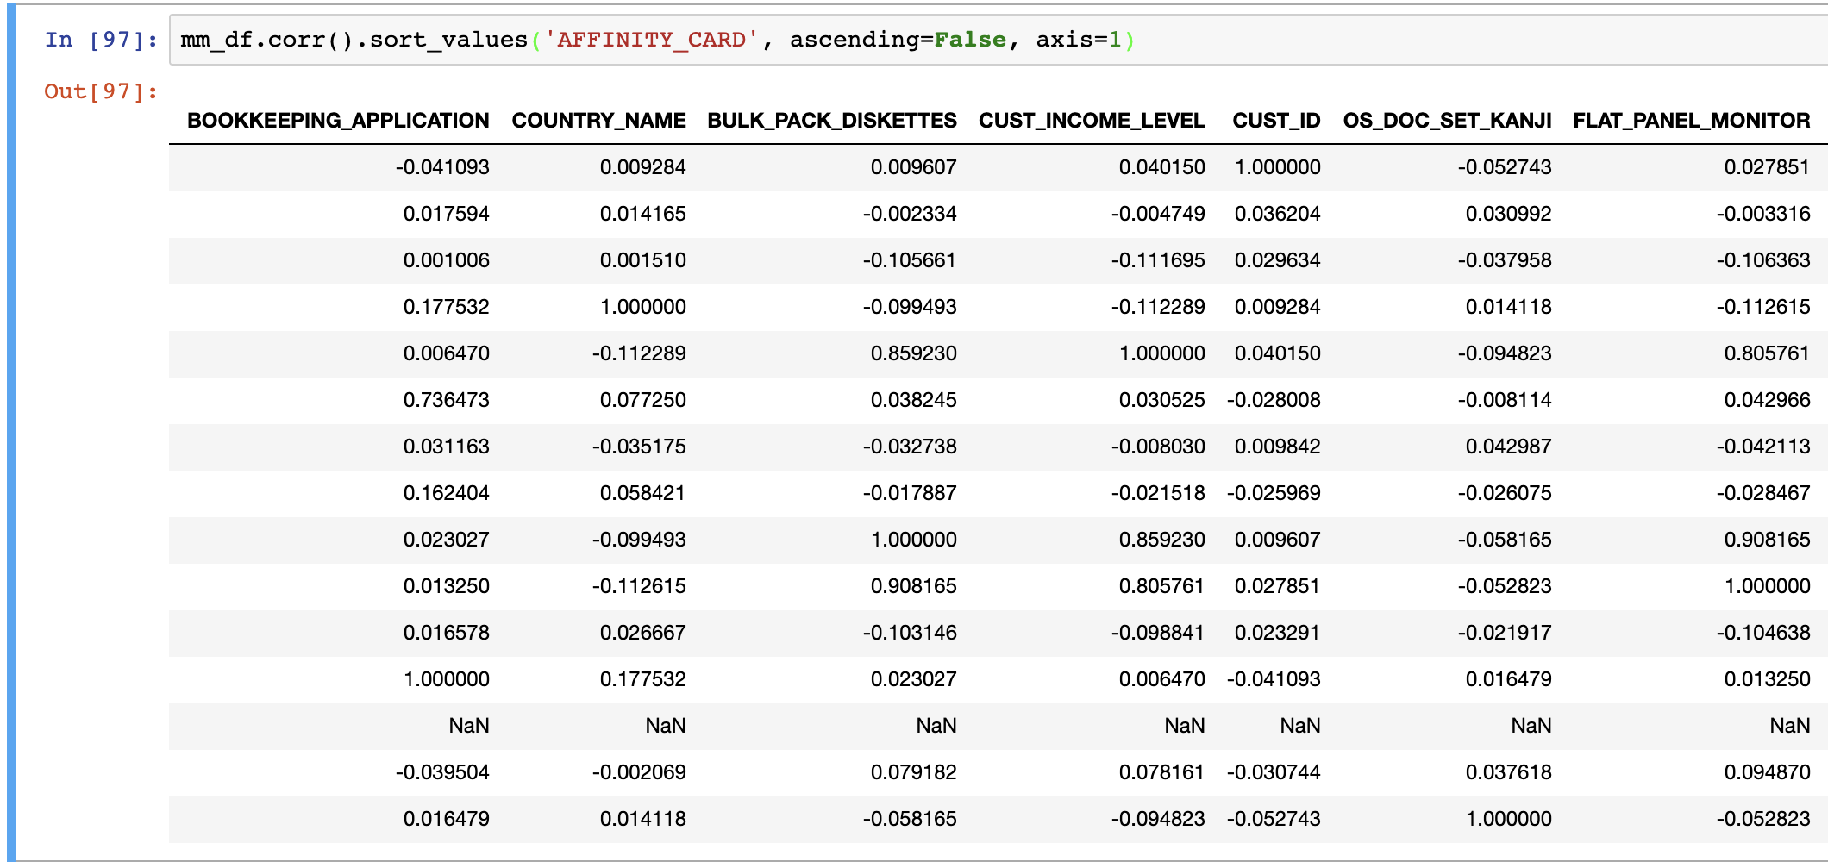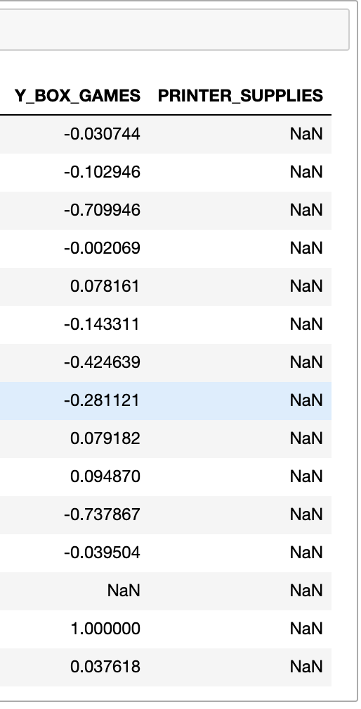

To further assess how the variables, correlate with the target variable, it is easier to have a visual representation of a correlation heatmap which can be programmed in python. This will show which of the variables have a better relationship with the target variable.

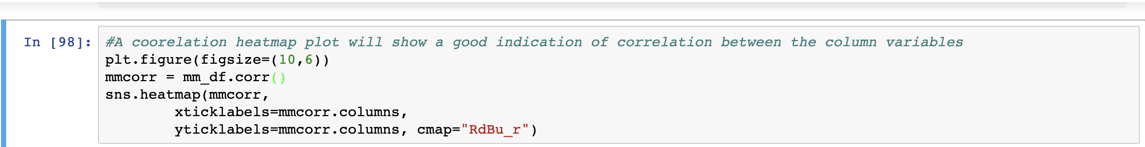

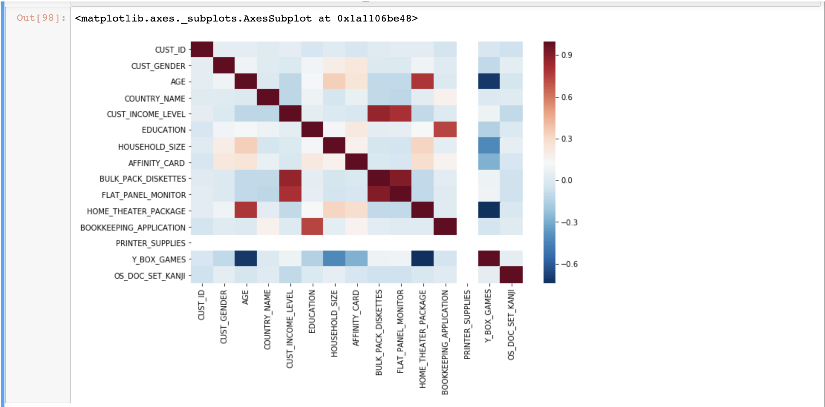

The above correlation plot defines how the variables and target variable relate with each other. If there is any correlation with the target variable (**AFFINITY_CARD**). The plot above confirms that there is little correlation but some correlation with the **CUST_INCOME_LEVEL, AGE, EDUCATION** and a very minor correlation with **HOUSEHOLD_SIZE** and **HOME_THEATRE_PACKAGE**

### **Euclidean Distance**

To calculate the Euclidean distance, there are a number of way to calculate this when calculating between rows or datapoints in a pandas dataframe. One way is to import the pdist, squareform packages from the scipy.spatial.distance library

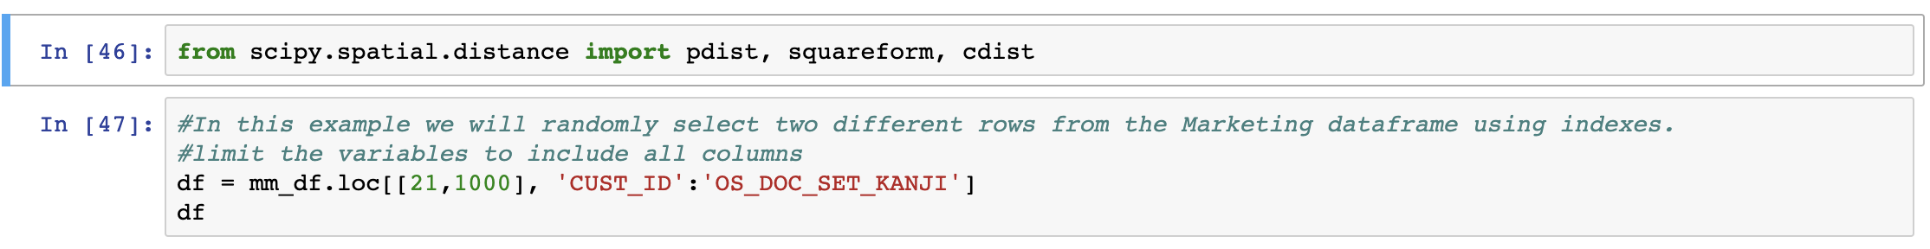

To calculate distance between two different datapoints within the dataframe, we randomly select any rows within the dataset. The rows here correspond to the different customers.

Using the pdist package the python library can calculate the Euclidean distance between any two variables of the customers. In the example from the correlation, I have calculated Euclidean distance between **AGE** and **HOME_THEATRE_PACKAGE**  as there is correlation between these two variables.

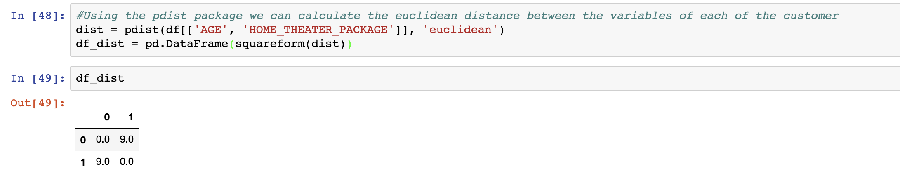

Another way of calculating the Euclidean Distance is by calling the numpy squareroot function on the variables.

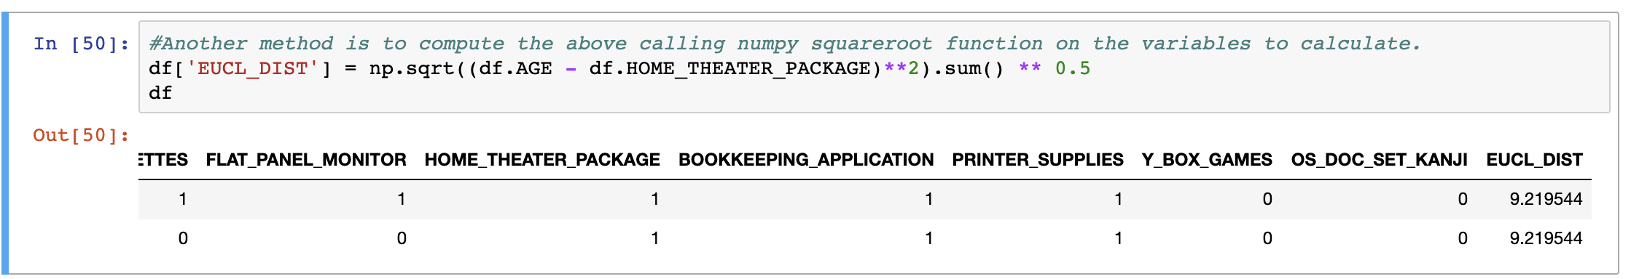

## **DATA EXPLORATION**

Distribution plots of some of the categorical variables of Marketing data.

The program below plots the distribution plots as subplots of any two chosen variables from the dataframe and their appropriate skewness with respect to the dataset following the data transformation.

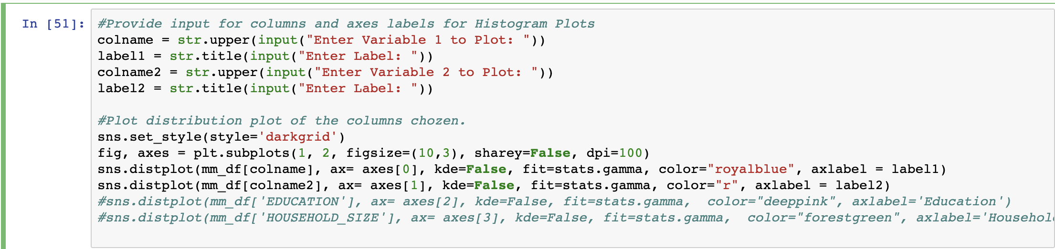

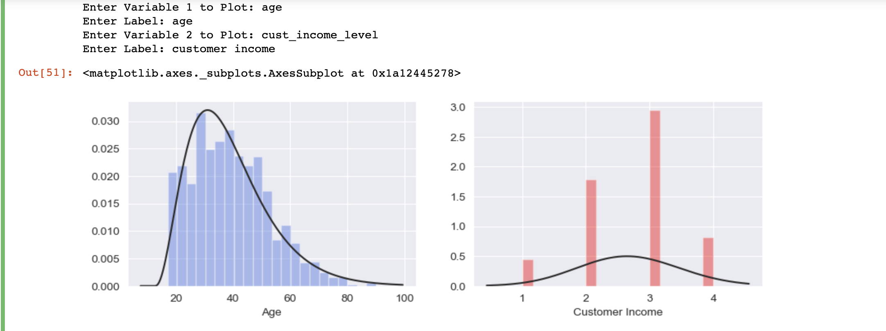

The program below allows one to plot a barchart of any two chosen X and Y variables from the dataframe.

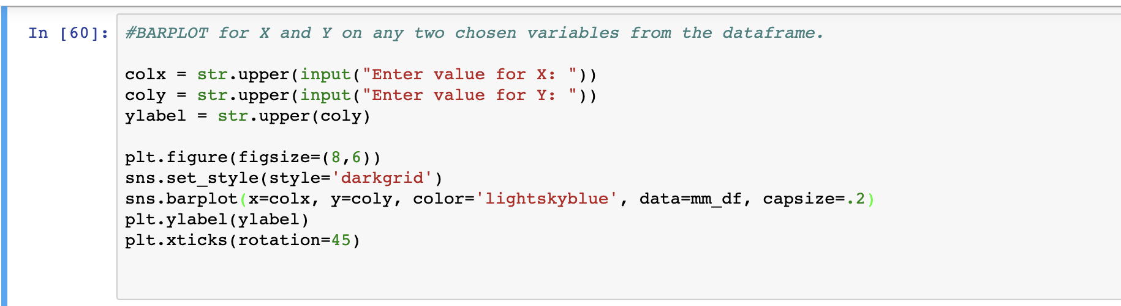

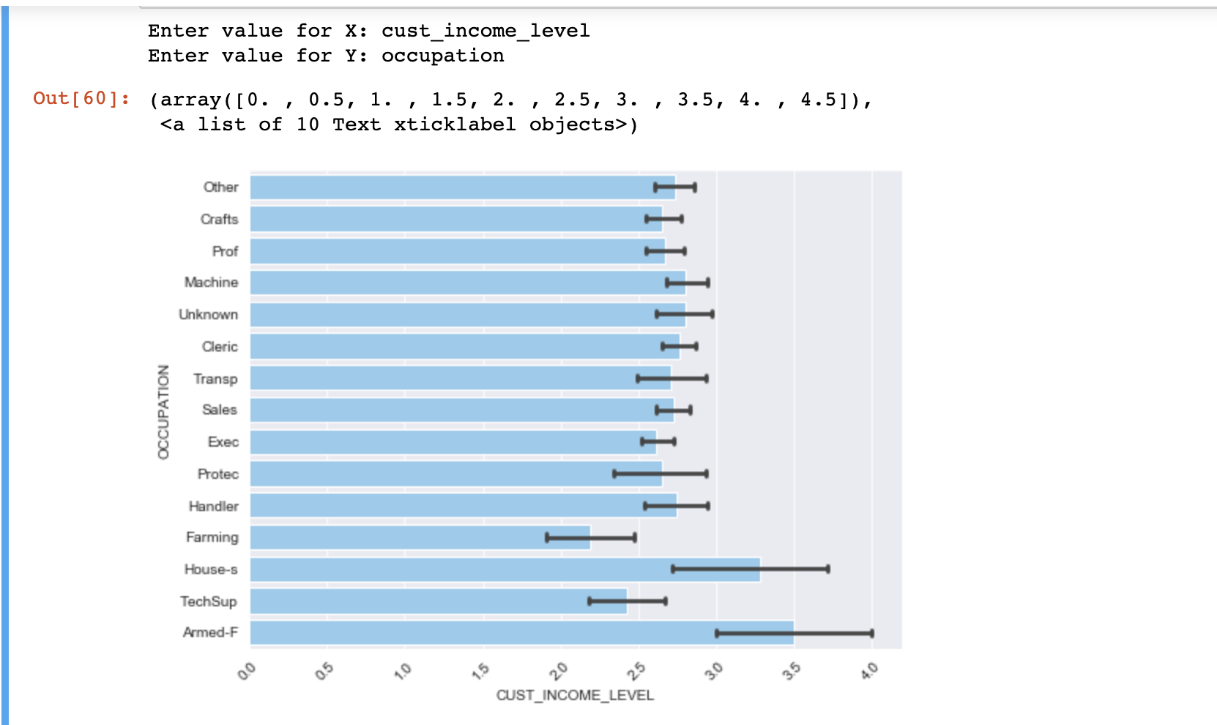

## **DATA MINING**

This section focuses on building predictive models to predict the **AFFINITY_CARD** target binary in the marketing campaign data. In this part of the assignment I have prepared two models using python for predictive modelling on the Target Variable.

1. Decision Tree Model
2. Logistic Regression Model

### **Decision Tree Model**

Python uses a set of libraries that you must import to run Decision Tree predictive modelling. The first steps is to import these libraries.

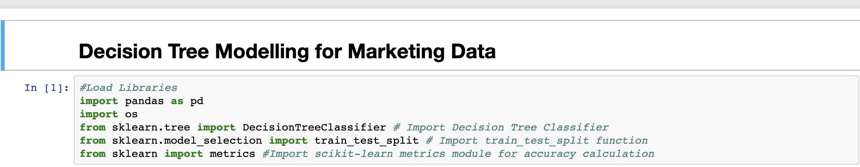

* Read the file location path and import the modified marketing data csv file that we have saved following all the transformations from the steps above (**“ModifiedMarketingClean.csv)**

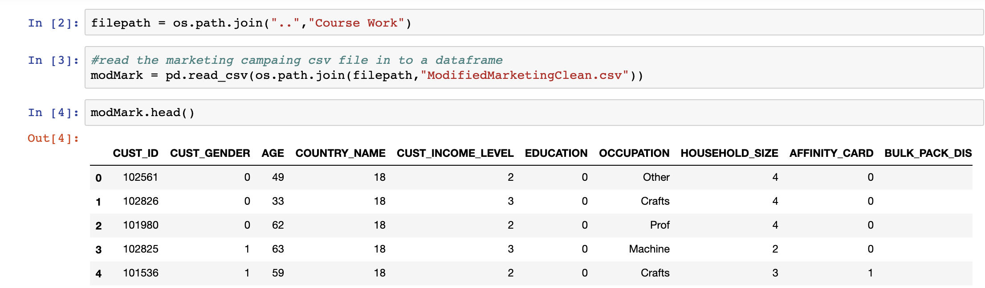

* Get the featured columns of the dataframe which will be used for the model. And define these columns against the target variable.

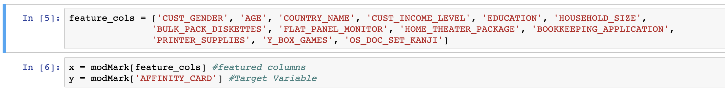

* Next we split the data into Training and Test Data and by how much the split will be. In my example I split the data as 60% Training and 40% Test.

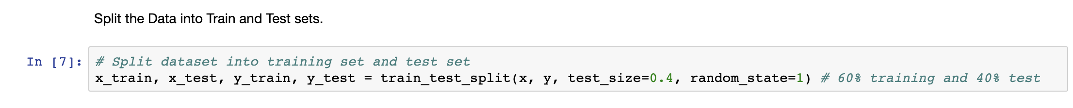

* Build the Decision Tree Model.
  + Create the classifier object using entropy criterion
  + Train the Decision Tree classifier
  + Predict the repost of the test classifier

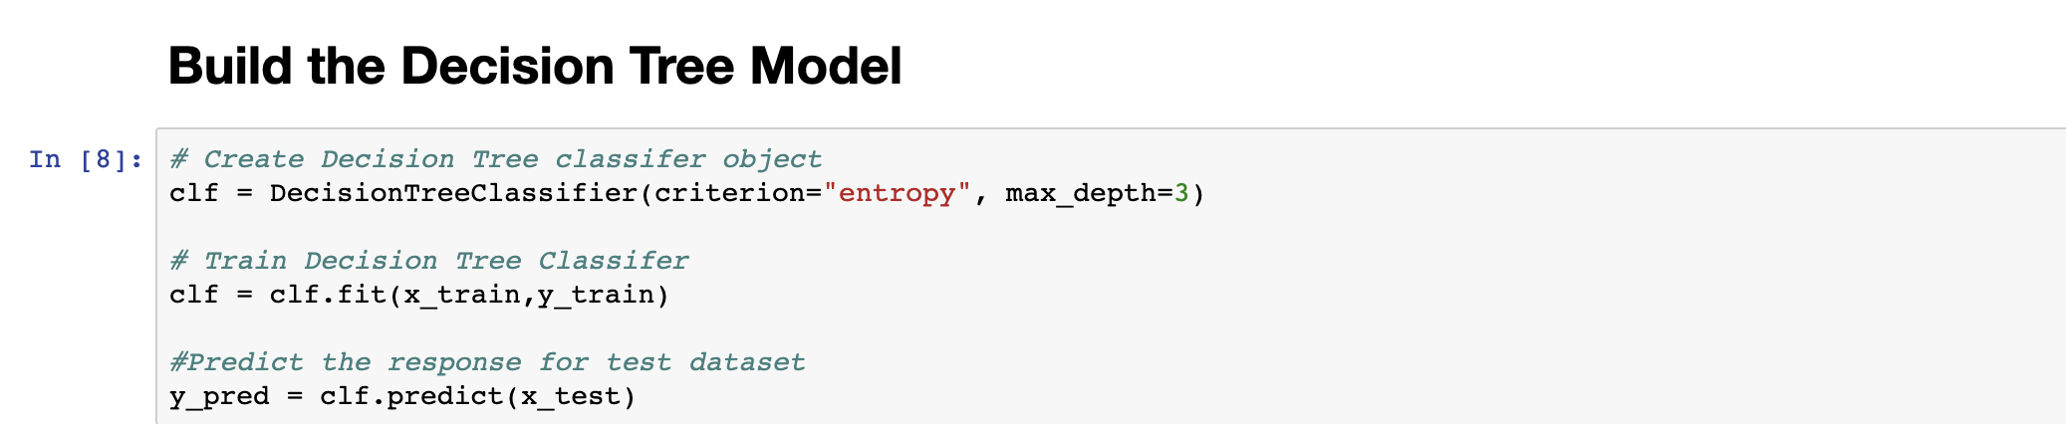

* Evaluate the Model.
  + Calculate the accuracy by comparing the test set values with the predicted values

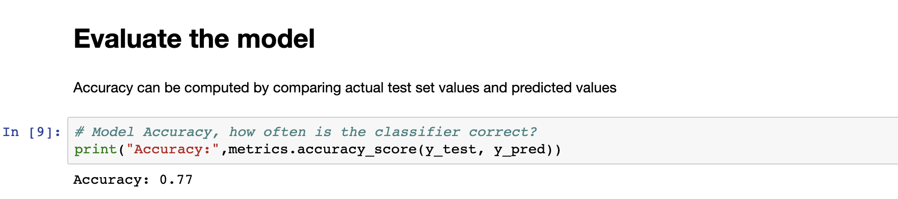

The above calculation shows the accuracy at 77%. Based on this, we can evaluate that the data is pretty weak in determining the outcome of the target variable based on the current set of categorical variables that we have with respect to the dataset. This is also evident when we executed the correlation plot which show relative little or no correlation with the target variable.

* Next build the decision tree model as a visual representation. Python has a set of packages (export_graphviz, StringIO, Image) that you need to import from the sklearn and IPython libraries that will assist in building the decision tree.

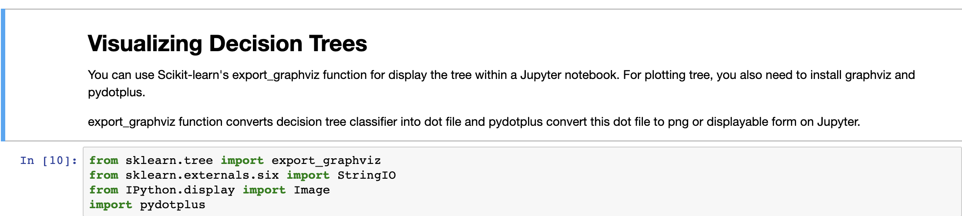

Run the program and export the graphic image to a .png file. (**MarketingData.png**)

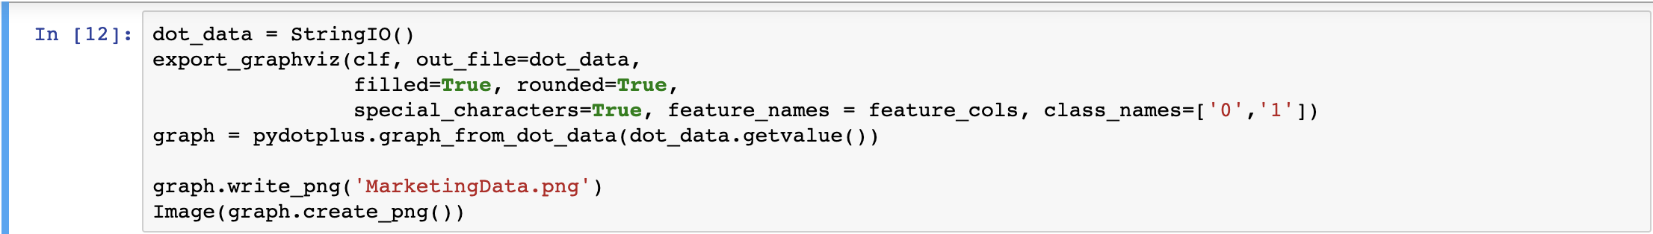

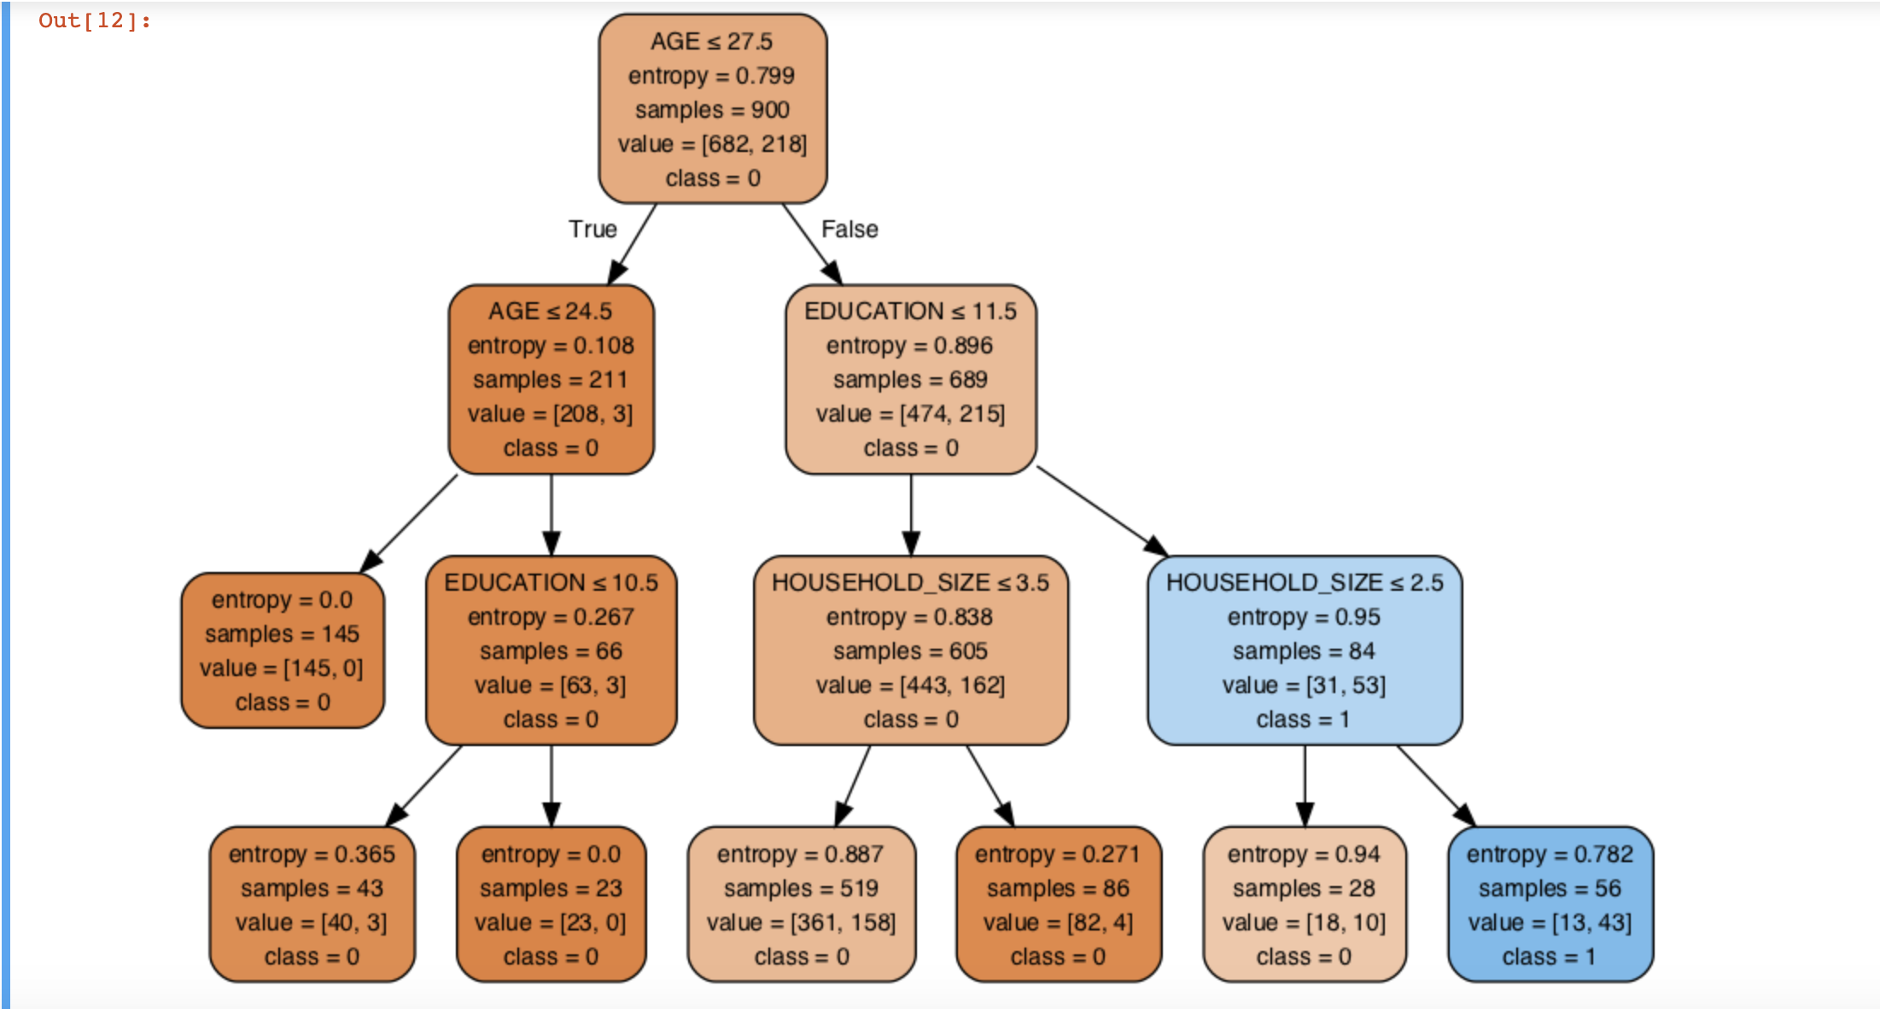

### **Logistic Regression**

The other model build around this data was the Logistic regression model to confirm how strong the data is with respect to the target variable.

* Perform the same set of action of importing libraries, defining file path location and reading the **ModifiedMarketingClean.csv**  file and defining the dataframe to run the regression model.

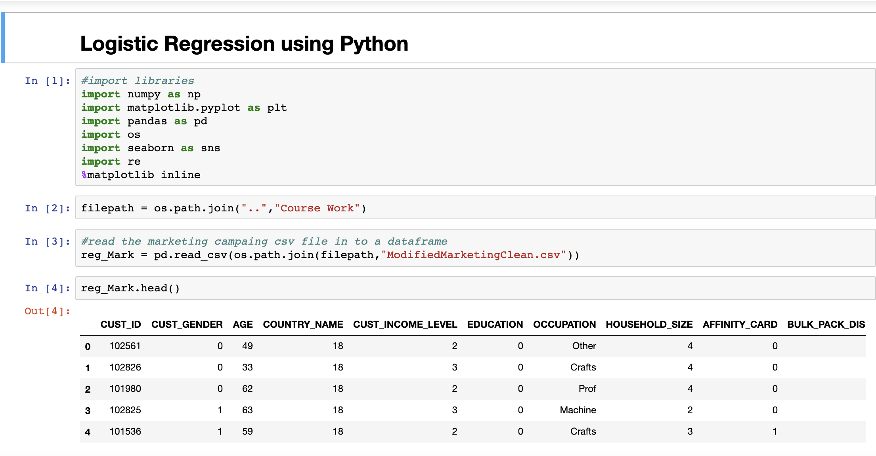

* Define the featured columns and the target column

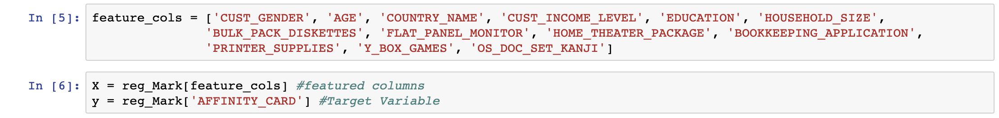

* Split the data into Train and Test data
  + Using the same Decision Tree criteria, split the data into 60% Train and 40% Test data.

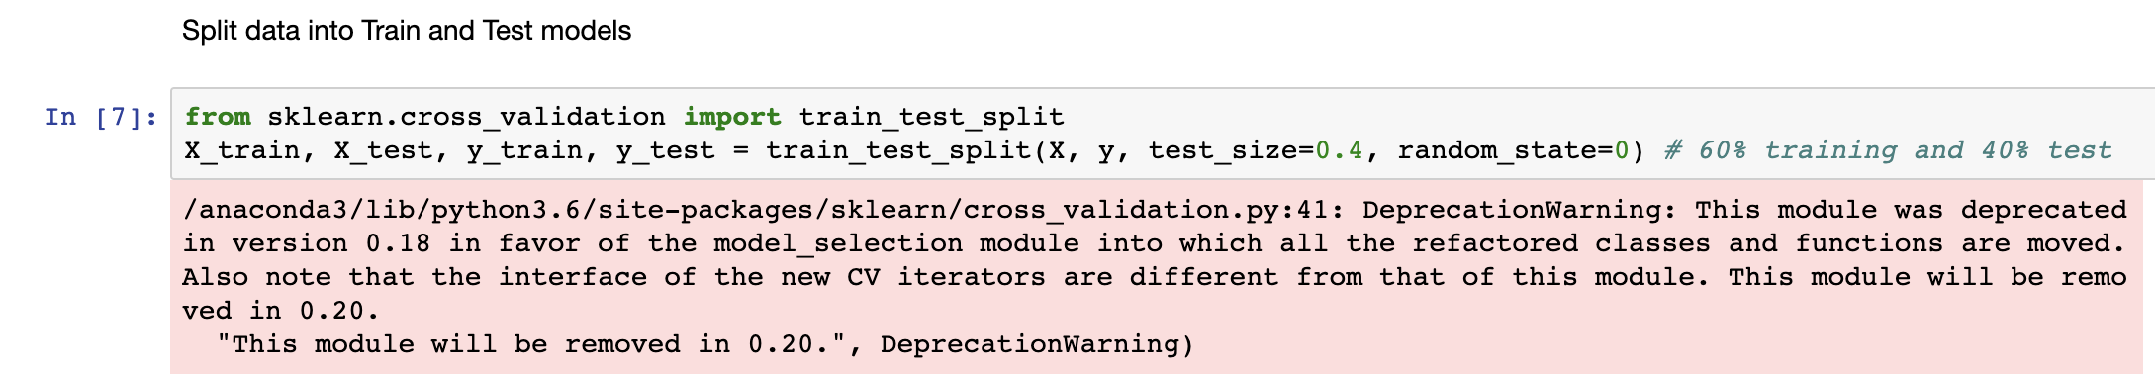

* Import the Logistic Regression module and create a Logistic Regression classifier object using the ***LogisticRegression()*** function
* Fit the model on the train dataset using ***fit()***and perform the prediction on the test data using ***predict()***functions.

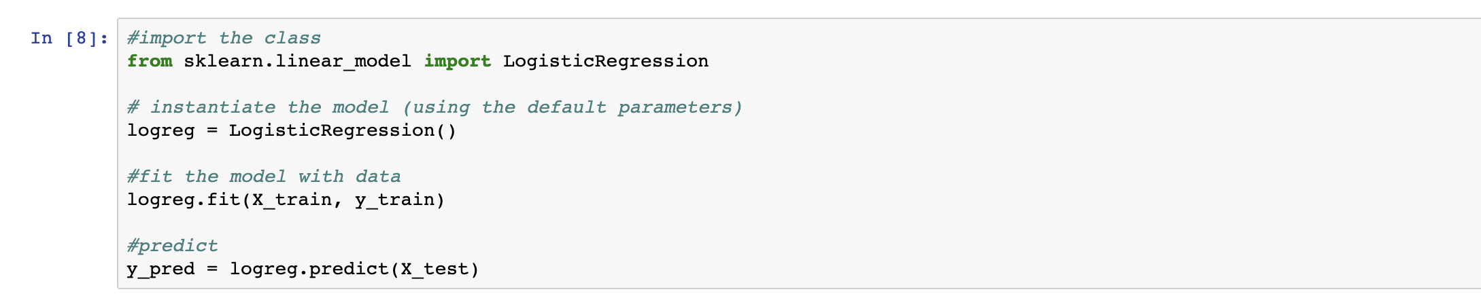

* Evaluate the model using Confusion Matrix.
  + The confusion matrix will evaluation the performance of the classification model. The fundamental of the confusion matrix is to predict the number of correct and incorrect predictions summed-up classwise.

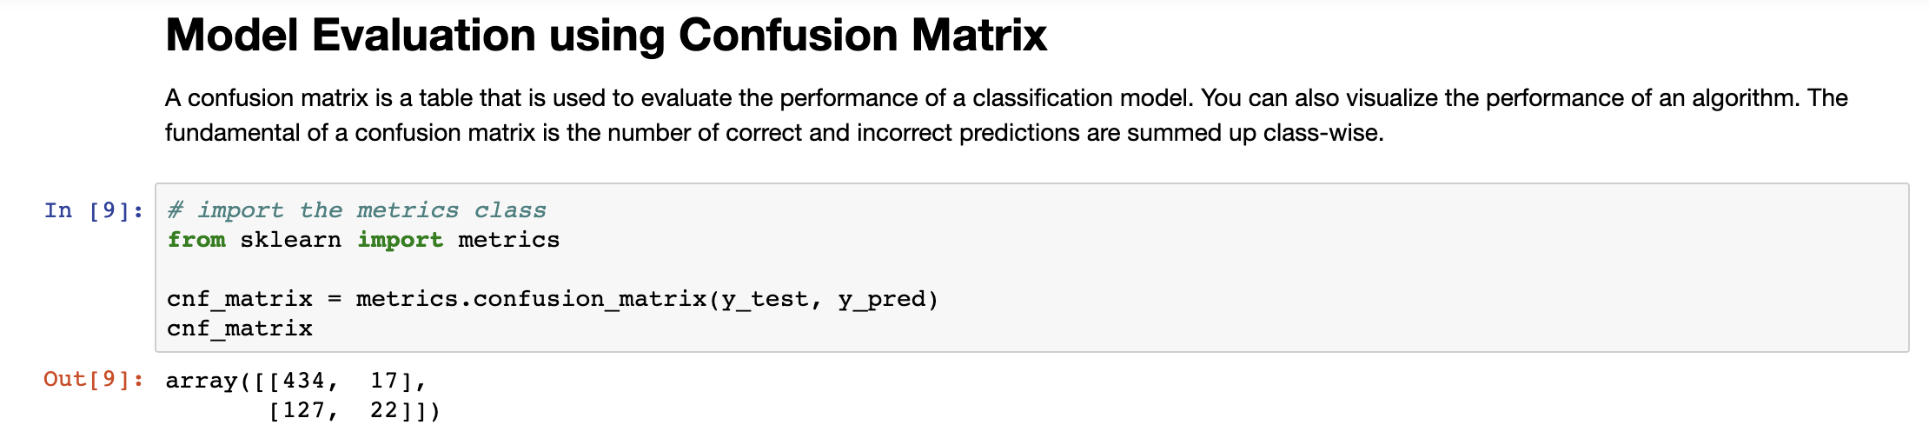

* Visualizing the Confusion Matrix using a Heatmap

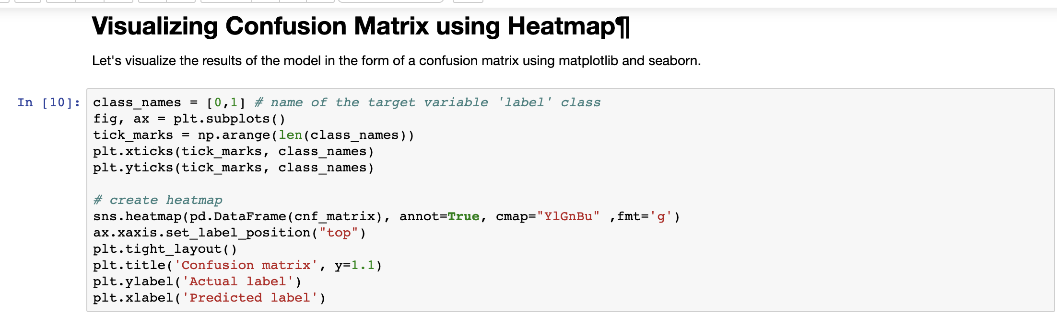

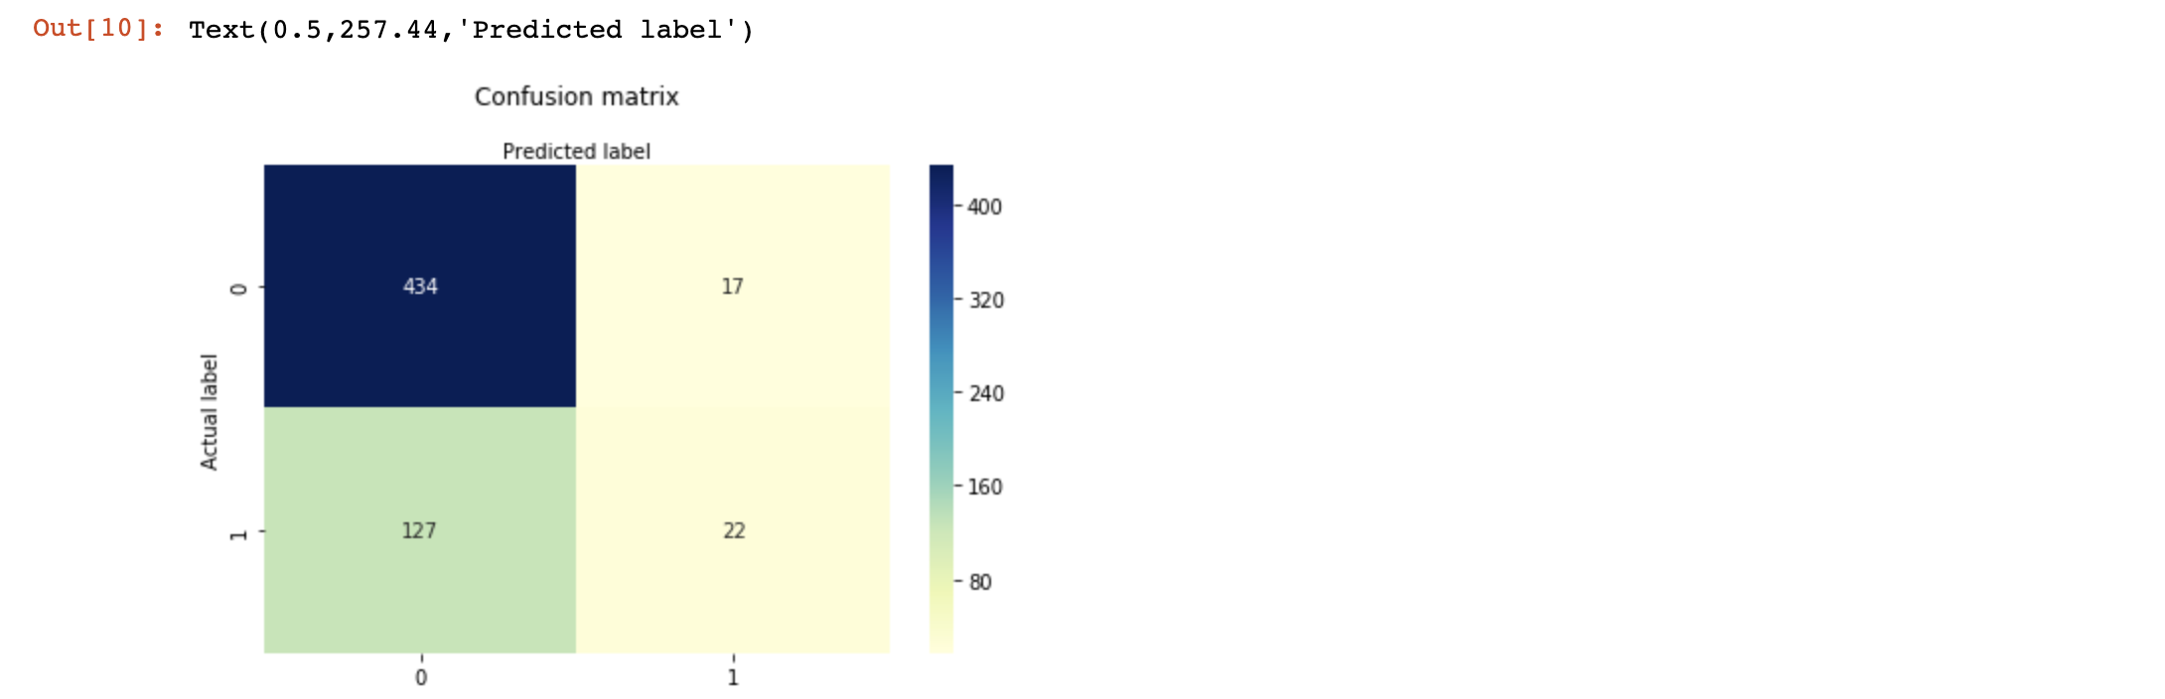

* Evaluation of Confusion Matrix

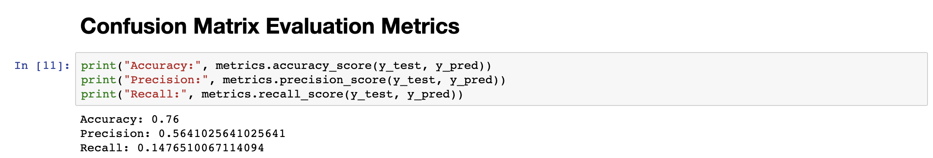

A classification rate of **76.0%** shows that the model is considered to be likely **Accurate**

**Precision:`** Precision is about being precise, i.e., how accurate your model is. In other words, you can say, when a model makes a prediction, how often it is correct. In this prediction case, when your Logistic Regression model predicted that under the circumstances is at `**56.4%`** meaning the model is not very precise in determining an pattern or trend within the data. It determines that the precision is almost half and half with respect to how to predict the model.

**Recall:** Recall value determines the likelihood of **AFFINITY_CARD** can be accurately predicted within the Test data and the result also shows a low rate of 14% which tell us that the model cannot be very accurate in predicting patterns of trends within the dataset.

* Plot the **ROC curve**
  + **ROC curve** will define the tradeoff between specificity and sensitivity.
  + Import the libraries.

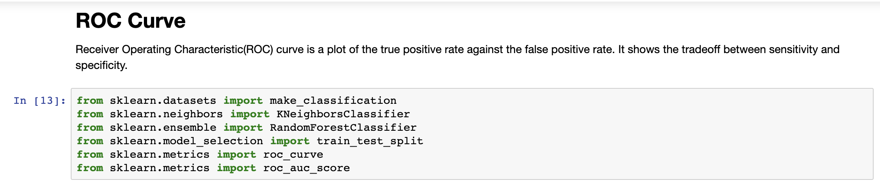

* Define a ROC Curve function to plot the curve

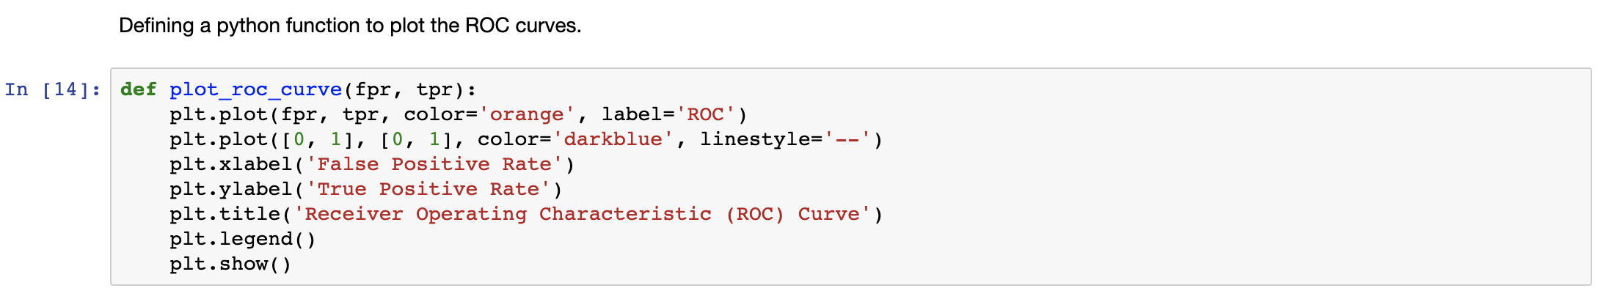

* Fit the model on the train data.
  + In this case I have used **RandomForestClassifier** to mode the data against.

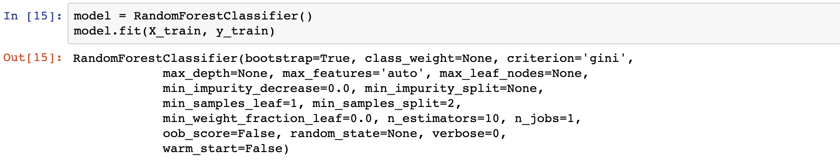

* Predict the probabilities of the test data

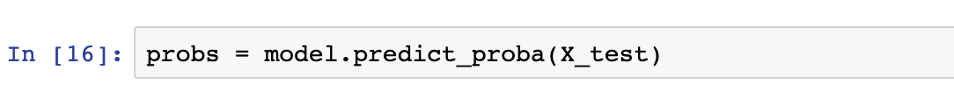

* Keep probabilities of positive class only

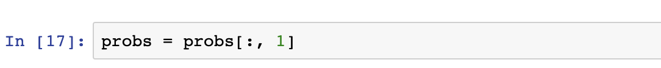

* Compute the AUC score using the ROC function.

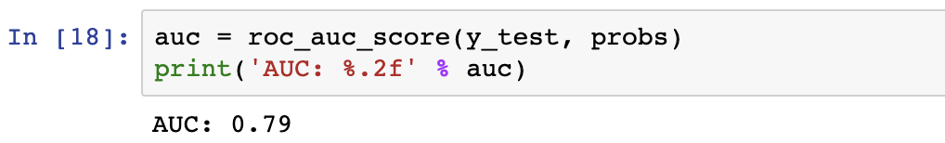

* Plot the ROC Curve using the defined function.

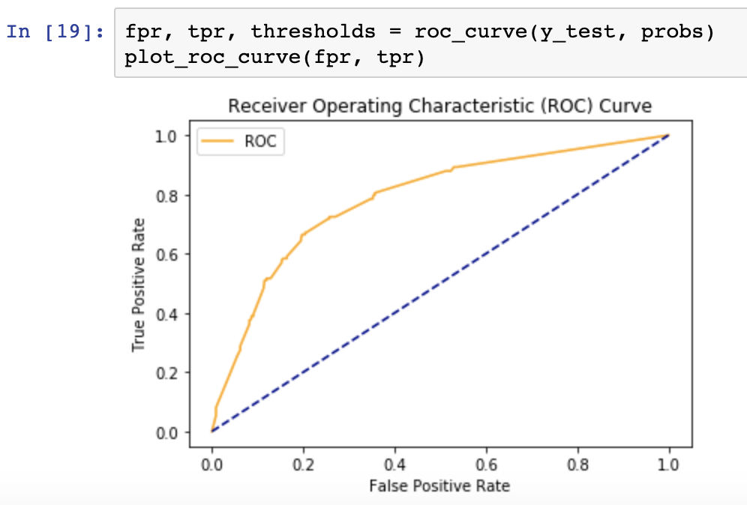

## **DISCUSSION AND REFLECTION OF WORK**

With respect to the course assignment, the main aspect was to assess and understand how python can help one address data, by importing files, understanding the data types, the limitations with the dataset and how to confirm dirty data and ways in which the data can be “cleaned” and then transformed before performing further analysis.

The following aspects of the course is where I found python incredibly powerful and flexible:

* **Data Cleaning:** With python, one can address what data is dirty and how such data can be cleaned either by stripping certain portions of data or replacing values which do not add any sense with other values. It also helps with addressing missing values which can be replaced with any values one chooses to replace with or also dropping the data altogether. From the csv file provided, it was evident that there was some cleanup required like addressing missing values, stripping unwanted characters and substituting values which did not make sense to the variables in question.
* **Data Transformation:** Python is very versatile when it comes to data transformations. The option of defining custom functions or using inbuilt functions will provide the same result. The versatility of python as a programming language makes it very convenient and powerful when working with big data.
* **Data Analysis & Exploration:** Python provide a range of inbuilt functions and libraries which can be imported to run your analysis on depending upon the criteria/business requirements. Python also provide an option to use MatplotLib or Seaborn libraries to plot data for further visual analytics and assessment. This combination is quite useful in understanding correlation of data and what sort of predictive mining methodologies can be implemented.
* **Data Mining:** Python has an immense array of libraries and packages that help with machine learning and deep learning methodologies. It is important to understand how these libraries and packages work prior to deploying them for the data that you need to assess.

Overall, the process shows how much time and effort is needed programming in python to perform cleaning, transformation, exploration, mining and analysis.